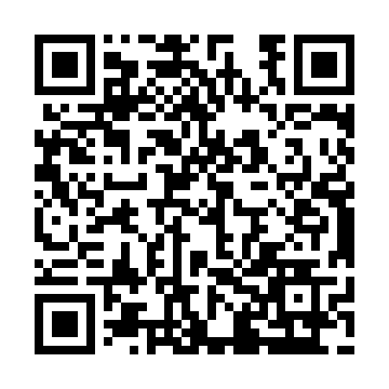
Prayer times for Battle Heights, Saskatchewan, Canada
Wed 1 May 2024 - Fri 31 May 2024
High Latitude Method: Angle Based Rule
Prayer Calculation Method: Islamic Society of North America
Asar Calculation Method: Hanafi

Date | Day | Fajr | Sunrise | Dhuhr | Asr | Maghrib | Isha
1 | Wed | 3:11 | 5:18 | 12:51 | 6:00 | 8:24 | 10:32
2 | Thu | 3:08 | 5:16 | 12:50 | 6:01 | 8:26 | 10:35
3 | Fri | 3:04 | 5:14 | 12:50 | 6:02 | 8:28 | 10:38
4 | Sat | 3:01 | 5:12 | 12:50 | 6:03 | 8:30 | 10:40
5 | Sun | 3:00 | 5:10 | 12:50 | 6:05 | 8:31 | 10:41
6 | Mon | 2:59 | 5:08 | 12:50 | 6:06 | 8:33 | 10:42
7 | Tue | 2:58 | 5:06 | 12:50 | 6:07 | 8:35 | 10:43
8 | Wed | 2:57 | 5:04 | 12:50 | 6:08 | 8:36 | 10:43
9 | Thu | 2:57 | 5:03 | 12:50 | 6:09 | 8:38 | 10:44
10 | Fri | 2:56 | 5:01 | 12:50 | 6:10 | 8:40 | 10:45
11 | Sat | 2:55 | 4:59 | 12:50 | 6:11 | 8:42 | 10:46
12 | Sun | 2:54 | 4:57 | 12:50 | 6:12 | 8:43 | 10:47
13 | Mon | 2:53 | 4:56 | 12:50 | 6:13 | 8:45 | 10:48
14 | Tue | 2:52 | 4:54 | 12:50 | 6:14 | 8:47 | 10:48
15 | Wed | 2:51 | 4:52 | 12:50 | 6:15 | 8:48 | 10:49
16 | Thu | 2:51 | 4:51 | 12:50 | 6:16 | 8:50 | 10:50
17 | Fri | 2:50 | 4:49 | 12:50 | 6:16 | 8:51 | 10:51
18 | Sat | 2:49 | 4:48 | 12:50 | 6:17 | 8:53 | 10:52
19 | Sun | 2:48 | 4:46 | 12:50 | 6:18 | 8:55 | 10:52
20 | Mon | 2:48 | 4:45 | 12:50 | 6:19 | 8:56 | 10:53
21 | Tue | 2:47 | 4:44 | 12:50 | 6:20 | 8:58 | 10:54
22 | Wed | 2:46 | 4:42 | 12:50 | 6:21 | 8:59 | 10:55
23 | Thu | 2:46 | 4:41 | 12:50 | 6:22 | 9:00 | 10:56
24 | Fri | 2:45 | 4:40 | 12:50 | 6:23 | 9:02 | 10:56
25 | Sat | 2:45 | 4:38 | 12:51 | 6:23 | 9:03 | 10:57
26 | Sun | 2:44 | 4:37 | 12:51 | 6:24 | 9:05 | 10:58
27 | Mon | 2:44 | 4:36 | 12:51 | 6:25 | 9:06 | 10:59
28 | Tue | 2:43 | 4:35 | 12:51 | 6:26 | 9:07 | 10:59
29 | Wed | 2:43 | 4:34 | 12:51 | 6:26 | 9:09 | 11:00
30 | Thu | 2:42 | 4:33 | 12:51 | 6:27 | 9:10 | 11:01
31 | Fri | 2:42 | 4:32 | 12:51 | 6:28 | 9:11 | 11:01
Prayer times provided by https://www.salahtimes.com

