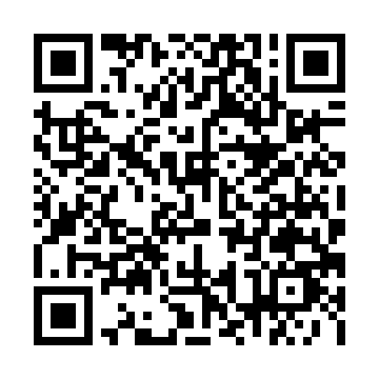
Prayer times for Tour-Boissinot, Quebec, Canada
Mon 1 Jul 2024 - Wed 31 Jul 2024
High Latitude Method: Angle Based Rule
Prayer Calculation Method: Islamic Society of North America
Asar Calculation Method: Hanafi

Date | Day | Fajr | Sunrise | Dhuhr | Asr | Maghrib | Isha
1 | Mon | 2:28 | 4:19 | 12:36 | 6:13 | 8:53 | 10:45
2 | Tue | 2:28 | 4:20 | 12:37 | 6:13 | 8:53 | 10:45
3 | Wed | 2:29 | 4:21 | 12:37 | 6:12 | 8:52 | 10:44
4 | Thu | 2:29 | 4:22 | 12:37 | 6:12 | 8:52 | 10:44
5 | Fri | 2:30 | 4:23 | 12:37 | 6:12 | 8:51 | 10:44
6 | Sat | 2:30 | 4:23 | 12:37 | 6:12 | 8:51 | 10:44
7 | Sun | 2:31 | 4:24 | 12:37 | 6:12 | 8:50 | 10:44
8 | Mon | 2:31 | 4:25 | 12:38 | 6:11 | 8:49 | 10:43
9 | Tue | 2:32 | 4:26 | 12:38 | 6:11 | 8:49 | 10:43
10 | Wed | 2:32 | 4:27 | 12:38 | 6:11 | 8:48 | 10:43
11 | Thu | 2:33 | 4:28 | 12:38 | 6:10 | 8:47 | 10:42
12 | Fri | 2:34 | 4:30 | 12:38 | 6:10 | 8:46 | 10:42
13 | Sat | 2:34 | 4:31 | 12:38 | 6:09 | 8:45 | 10:42
14 | Sun | 2:35 | 4:32 | 12:38 | 6:09 | 8:44 | 10:41
15 | Mon | 2:36 | 4:33 | 12:38 | 6:08 | 8:43 | 10:41
16 | Tue | 2:36 | 4:34 | 12:38 | 6:08 | 8:42 | 10:40
17 | Wed | 2:37 | 4:36 | 12:39 | 6:07 | 8:41 | 10:40
18 | Thu | 2:38 | 4:37 | 12:39 | 6:07 | 8:40 | 10:39
19 | Fri | 2:38 | 4:38 | 12:39 | 6:06 | 8:39 | 10:39
20 | Sat | 2:39 | 4:39 | 12:39 | 6:05 | 8:37 | 10:38
21 | Sun | 2:40 | 4:41 | 12:39 | 6:05 | 8:36 | 10:37
22 | Mon | 2:40 | 4:42 | 12:39 | 6:04 | 8:35 | 10:37
23 | Tue | 2:41 | 4:44 | 12:39 | 6:03 | 8:34 | 10:36
24 | Wed | 2:42 | 4:45 | 12:39 | 6:02 | 8:32 | 10:35
25 | Thu | 2:42 | 4:46 | 12:39 | 6:02 | 8:31 | 10:35
26 | Fri | 2:43 | 4:48 | 12:39 | 6:01 | 8:29 | 10:34
27 | Sat | 2:44 | 4:49 | 12:39 | 6:00 | 8:28 | 10:33
28 | Sun | 2:45 | 4:51 | 12:39 | 5:59 | 8:26 | 10:32
29 | Mon | 2:45 | 4:52 | 12:39 | 5:58 | 8:25 | 10:32
30 | Tue | 2:46 | 4:54 | 12:39 | 5:57 | 8:23 | 10:31
31 | Wed | 2:47 | 4:55 | 12:39 | 5:56 | 8:21 | 10:30
Prayer times provided by https://www.salahtimes.com

