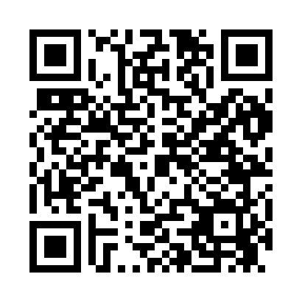
Prayer times for Belchertown, Massachusetts, USA
Mon 1 Jul 2024 - Wed 31 Jul 2024
High Latitude Method: Angle Based Rule
Prayer Calculation Method: Islamic Society of North America
Asar Calculation Method: Shafi

Date | Day | Fajr | Sunrise | Dhuhr | Asr | Maghrib | Isha
1 | Mon | 3:33 | 5:17 | 12:54 | 4:57 | 8:30 | 10:14
2 | Tue | 3:34 | 5:18 | 12:54 | 4:57 | 8:30 | 10:13
3 | Wed | 3:35 | 5:18 | 12:54 | 4:57 | 8:29 | 10:13
4 | Thu | 3:36 | 5:19 | 12:54 | 4:57 | 8:29 | 10:12
5 | Fri | 3:37 | 5:20 | 12:54 | 4:57 | 8:29 | 10:12
6 | Sat | 3:37 | 5:20 | 12:55 | 4:57 | 8:29 | 10:11
7 | Sun | 3:38 | 5:21 | 12:55 | 4:57 | 8:28 | 10:10
8 | Mon | 3:39 | 5:22 | 12:55 | 4:57 | 8:28 | 10:10
9 | Tue | 3:40 | 5:22 | 12:55 | 4:57 | 8:27 | 10:09
10 | Wed | 3:42 | 5:23 | 12:55 | 4:57 | 8:27 | 10:08
11 | Thu | 3:43 | 5:24 | 12:55 | 4:57 | 8:26 | 10:07
12 | Fri | 3:44 | 5:25 | 12:55 | 4:57 | 8:26 | 10:06
13 | Sat | 3:45 | 5:25 | 12:55 | 4:57 | 8:25 | 10:05
14 | Sun | 3:46 | 5:26 | 12:56 | 4:57 | 8:25 | 10:04
15 | Mon | 3:47 | 5:27 | 12:56 | 4:57 | 8:24 | 10:03
16 | Tue | 3:49 | 5:28 | 12:56 | 4:57 | 8:23 | 10:02
17 | Wed | 3:50 | 5:29 | 12:56 | 4:57 | 8:23 | 10:01
18 | Thu | 3:51 | 5:30 | 12:56 | 4:57 | 8:22 | 10:00
19 | Fri | 3:52 | 5:30 | 12:56 | 4:56 | 8:21 | 9:59
20 | Sat | 3:54 | 5:31 | 12:56 | 4:56 | 8:20 | 9:58
21 | Sun | 3:55 | 5:32 | 12:56 | 4:56 | 8:19 | 9:56
22 | Mon | 3:57 | 5:33 | 12:56 | 4:56 | 8:19 | 9:55
23 | Tue | 3:58 | 5:34 | 12:56 | 4:56 | 8:18 | 9:54
24 | Wed | 3:59 | 5:35 | 12:56 | 4:55 | 8:17 | 9:52
25 | Thu | 4:01 | 5:36 | 12:56 | 4:55 | 8:16 | 9:51
26 | Fri | 4:02 | 5:37 | 12:56 | 4:55 | 8:15 | 9:49
27 | Sat | 4:04 | 5:38 | 12:56 | 4:55 | 8:14 | 9:48
28 | Sun | 4:05 | 5:39 | 12:56 | 4:54 | 8:13 | 9:46
29 | Mon | 4:06 | 5:40 | 12:56 | 4:54 | 8:12 | 9:45
30 | Tue | 4:08 | 5:41 | 12:56 | 4:53 | 8:11 | 9:43
31 | Wed | 4:09 | 5:42 | 12:56 | 4:53 | 8:09 | 9:42
Prayer times provided by https://www.salahtimes.com

