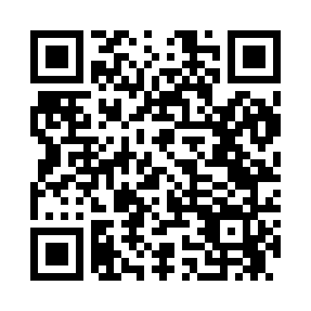
Prayer times for Zena, New York, USA
Wed 1 May 2024 - Fri 31 May 2024
High Latitude Method: Angle Based Rule
Prayer Calculation Method: Islamic Society of North America
Asar Calculation Method: Shafi

Date | Day | Fajr | Sunrise | Dhuhr | Asr | Maghrib | Isha
1 | Wed | 4:24 | 5:51 | 12:53 | 4:46 | 7:56 | 9:24
2 | Thu | 4:22 | 5:50 | 12:53 | 4:47 | 7:57 | 9:25
3 | Fri | 4:20 | 5:49 | 12:53 | 4:47 | 7:58 | 9:27
4 | Sat | 4:19 | 5:48 | 12:53 | 4:47 | 7:59 | 9:28
5 | Sun | 4:17 | 5:46 | 12:53 | 4:48 | 8:00 | 9:30
6 | Mon | 4:15 | 5:45 | 12:53 | 4:48 | 8:01 | 9:31
7 | Tue | 4:14 | 5:44 | 12:53 | 4:48 | 8:02 | 9:33
8 | Wed | 4:12 | 5:43 | 12:53 | 4:49 | 8:03 | 9:34
9 | Thu | 4:11 | 5:42 | 12:53 | 4:49 | 8:04 | 9:36
10 | Fri | 4:09 | 5:40 | 12:53 | 4:49 | 8:05 | 9:37
11 | Sat | 4:07 | 5:39 | 12:53 | 4:50 | 8:07 | 9:39
12 | Sun | 4:06 | 5:38 | 12:53 | 4:50 | 8:08 | 9:40
13 | Mon | 4:04 | 5:37 | 12:53 | 4:50 | 8:09 | 9:42
14 | Tue | 4:03 | 5:36 | 12:53 | 4:50 | 8:10 | 9:43
15 | Wed | 4:02 | 5:35 | 12:53 | 4:51 | 8:11 | 9:45
16 | Thu | 4:00 | 5:34 | 12:53 | 4:51 | 8:12 | 9:46
17 | Fri | 3:59 | 5:33 | 12:53 | 4:51 | 8:13 | 9:47
18 | Sat | 3:57 | 5:32 | 12:53 | 4:52 | 8:14 | 9:49
19 | Sun | 3:56 | 5:32 | 12:53 | 4:52 | 8:15 | 9:50
20 | Mon | 3:55 | 5:31 | 12:53 | 4:52 | 8:16 | 9:52
21 | Tue | 3:54 | 5:30 | 12:53 | 4:53 | 8:17 | 9:53
22 | Wed | 3:52 | 5:29 | 12:53 | 4:53 | 8:17 | 9:54
23 | Thu | 3:51 | 5:28 | 12:53 | 4:53 | 8:18 | 9:56
24 | Fri | 3:50 | 5:28 | 12:53 | 4:54 | 8:19 | 9:57
25 | Sat | 3:49 | 5:27 | 12:53 | 4:54 | 8:20 | 9:58
26 | Sun | 3:48 | 5:26 | 12:53 | 4:54 | 8:21 | 10:00
27 | Mon | 3:47 | 5:26 | 12:54 | 4:55 | 8:22 | 10:01
28 | Tue | 3:46 | 5:25 | 12:54 | 4:55 | 8:23 | 10:02
29 | Wed | 3:45 | 5:24 | 12:54 | 4:55 | 8:24 | 10:03
30 | Thu | 3:44 | 5:24 | 12:54 | 4:55 | 8:24 | 10:04
31 | Fri | 3:43 | 5:23 | 12:54 | 4:56 | 8:25 | 10:06
Prayer times provided by https://www.salahtimes.com

