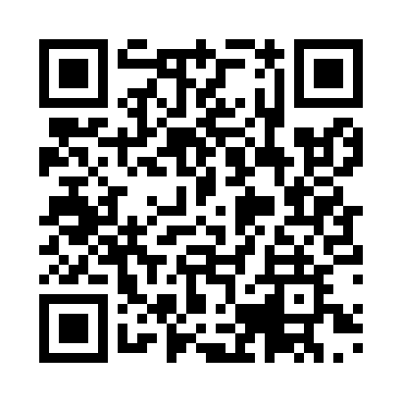
Prayer times for Kumejima, Japan
Wed 1 May 2024 - Fri 31 May 2024
High Latitude Method: None
Prayer Calculation Method: Muslim World League
Asar Calculation Method: Shafi

Date | Day | Fajr | Sunrise | Dhuhr | Asr | Maghrib | Isha
1 | Wed | 4:32 | 5:55 | 12:30 | 4:00 | 7:05 | 8:23
2 | Thu | 4:31 | 5:55 | 12:30 | 4:00 | 7:05 | 8:24
3 | Fri | 4:30 | 5:54 | 12:30 | 4:00 | 7:06 | 8:24
4 | Sat | 4:29 | 5:53 | 12:30 | 4:00 | 7:06 | 8:25
5 | Sun | 4:28 | 5:52 | 12:29 | 4:00 | 7:07 | 8:26
6 | Mon | 4:28 | 5:52 | 12:29 | 4:00 | 7:08 | 8:27
7 | Tue | 4:27 | 5:51 | 12:29 | 3:59 | 7:08 | 8:27
8 | Wed | 4:26 | 5:50 | 12:29 | 3:59 | 7:09 | 8:28
9 | Thu | 4:25 | 5:50 | 12:29 | 3:59 | 7:09 | 8:29
10 | Fri | 4:24 | 5:49 | 12:29 | 3:59 | 7:10 | 8:30
11 | Sat | 4:23 | 5:48 | 12:29 | 3:59 | 7:10 | 8:30
12 | Sun | 4:22 | 5:48 | 12:29 | 3:59 | 7:11 | 8:31
13 | Mon | 4:22 | 5:47 | 12:29 | 3:58 | 7:11 | 8:32
14 | Tue | 4:21 | 5:47 | 12:29 | 3:58 | 7:12 | 8:33
15 | Wed | 4:20 | 5:46 | 12:29 | 3:58 | 7:12 | 8:33
16 | Thu | 4:19 | 5:46 | 12:29 | 3:58 | 7:13 | 8:34
17 | Fri | 4:19 | 5:45 | 12:29 | 3:58 | 7:14 | 8:35
18 | Sat | 4:18 | 5:45 | 12:29 | 3:58 | 7:14 | 8:36
19 | Sun | 4:17 | 5:44 | 12:29 | 3:58 | 7:15 | 8:36
20 | Mon | 4:17 | 5:44 | 12:29 | 3:58 | 7:15 | 8:37
21 | Tue | 4:16 | 5:43 | 12:29 | 3:58 | 7:16 | 8:38
22 | Wed | 4:15 | 5:43 | 12:29 | 3:58 | 7:16 | 8:38
23 | Thu | 4:15 | 5:43 | 12:30 | 3:58 | 7:17 | 8:39
24 | Fri | 4:14 | 5:42 | 12:30 | 3:58 | 7:17 | 8:40
25 | Sat | 4:14 | 5:42 | 12:30 | 3:57 | 7:18 | 8:41
26 | Sun | 4:13 | 5:42 | 12:30 | 3:57 | 7:18 | 8:41
27 | Mon | 4:13 | 5:41 | 12:30 | 3:57 | 7:19 | 8:42
28 | Tue | 4:12 | 5:41 | 12:30 | 3:57 | 7:19 | 8:43
29 | Wed | 4:12 | 5:41 | 12:30 | 3:57 | 7:20 | 8:43
30 | Thu | 4:12 | 5:41 | 12:30 | 3:57 | 7:20 | 8:44
31 | Fri | 4:11 | 5:40 | 12:31 | 3:57 | 7:21 | 8:45
Prayer times provided by https://www.salahtimes.com

