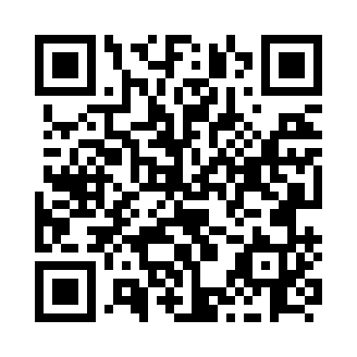
Prayer times for Bell Rock, Northwest Territories, Canada
Wed 1 May 2024 - Fri 31 May 2024
High Latitude Method: Angle Based Rule
Prayer Calculation Method: Islamic Society of North America
Asar Calculation Method: Hanafi

Date | Day | Fajr | Sunrise | Dhuhr | Asr | Maghrib | Isha
1 | Wed | 3:25 | 5:24 | 1:25 | 6:44 | 9:28 | 11:27
2 | Thu | 3:24 | 5:21 | 1:25 | 6:45 | 9:31 | 11:28
3 | Fri | 3:22 | 5:19 | 1:25 | 6:47 | 9:33 | 11:29
4 | Sat | 3:21 | 5:16 | 1:25 | 6:48 | 9:36 | 11:31
5 | Sun | 3:19 | 5:13 | 1:25 | 6:49 | 9:38 | 11:32
6 | Mon | 3:18 | 5:11 | 1:25 | 6:51 | 9:40 | 11:33
7 | Tue | 3:17 | 5:08 | 1:25 | 6:52 | 9:43 | 11:34
8 | Wed | 3:16 | 5:06 | 1:25 | 6:53 | 9:45 | 11:35
9 | Thu | 3:14 | 5:03 | 1:25 | 6:55 | 9:48 | 11:37
10 | Fri | 3:13 | 5:01 | 1:25 | 6:56 | 9:50 | 11:38
11 | Sat | 3:12 | 4:58 | 1:25 | 6:57 | 9:53 | 11:39
12 | Sun | 3:11 | 4:56 | 1:25 | 6:59 | 9:55 | 11:40
13 | Mon | 3:09 | 4:53 | 1:25 | 7:00 | 9:57 | 11:41
14 | Tue | 3:08 | 4:51 | 1:25 | 7:01 | 10:00 | 11:43
15 | Wed | 3:07 | 4:49 | 1:25 | 7:03 | 10:02 | 11:44
16 | Thu | 3:06 | 4:46 | 1:25 | 7:04 | 10:04 | 11:45
17 | Fri | 3:05 | 4:44 | 1:25 | 7:05 | 10:07 | 11:46
18 | Sat | 3:04 | 4:42 | 1:25 | 7:06 | 10:09 | 11:47
19 | Sun | 3:03 | 4:40 | 1:25 | 7:07 | 10:11 | 11:48
20 | Mon | 3:02 | 4:38 | 1:25 | 7:09 | 10:13 | 11:49
21 | Tue | 3:01 | 4:35 | 1:25 | 7:10 | 10:16 | 11:51
22 | Wed | 3:00 | 4:33 | 1:25 | 7:11 | 10:18 | 11:52
23 | Thu | 2:59 | 4:31 | 1:25 | 7:12 | 10:20 | 11:53
24 | Fri | 2:58 | 4:30 | 1:25 | 7:13 | 10:22 | 11:54
25 | Sat | 2:57 | 4:28 | 1:25 | 7:14 | 10:24 | 11:55
26 | Sun | 2:56 | 4:26 | 1:26 | 7:15 | 10:26 | 11:56
27 | Mon | 2:55 | 4:24 | 1:26 | 7:16 | 10:28 | 11:57
28 | Tue | 2:54 | 4:22 | 1:26 | 7:17 | 10:30 | 11:58
29 | Wed | 2:54 | 4:21 | 1:26 | 7:18 | 10:32 | 11:59
30 | Thu | 2:53 | 4:19 | 1:26 | 7:19 | 10:34 | 12:00
31 | Fri | 2:52 | 4:18 | 1:26 | 7:20 | 10:36 | 12:01
Prayer times provided by https://www.salahtimes.com

