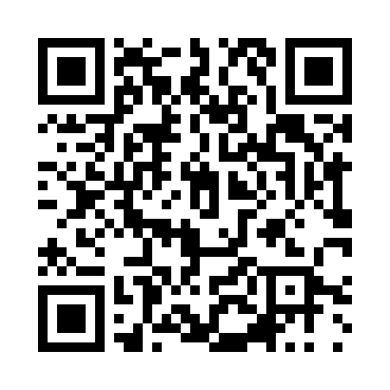
Prayer times for Lekhovo, Bulgaria
Mon 1 Apr 2024 - Tue 30 Apr 2024
High Latitude Method: Angle Based Rule
Prayer Calculation Method: Muslim World League
Asar Calculation Method: Hanafi

Date | Day | Fajr | Sunrise | Dhuhr | Asr | Maghrib | Isha
1 | Mon | 5:34 | 7:09 | 1:30 | 5:59 | 7:52 | 9:21
2 | Tue | 5:32 | 7:07 | 1:30 | 6:00 | 7:53 | 9:22
3 | Wed | 5:30 | 7:05 | 1:29 | 6:01 | 7:54 | 9:24
4 | Thu | 5:28 | 7:04 | 1:29 | 6:02 | 7:55 | 9:25
5 | Fri | 5:26 | 7:02 | 1:29 | 6:02 | 7:56 | 9:26
6 | Sat | 5:24 | 7:00 | 1:28 | 6:03 | 7:57 | 9:28
7 | Sun | 5:22 | 6:59 | 1:28 | 6:04 | 7:58 | 9:29
8 | Mon | 5:20 | 6:57 | 1:28 | 6:05 | 7:59 | 9:31
9 | Tue | 5:18 | 6:56 | 1:28 | 6:05 | 8:00 | 9:32
10 | Wed | 5:16 | 6:54 | 1:27 | 6:06 | 8:01 | 9:33
11 | Thu | 5:14 | 6:52 | 1:27 | 6:07 | 8:02 | 9:35
12 | Fri | 5:12 | 6:51 | 1:27 | 6:07 | 8:03 | 9:36
13 | Sat | 5:10 | 6:49 | 1:26 | 6:08 | 8:05 | 9:37
14 | Sun | 5:08 | 6:48 | 1:26 | 6:09 | 8:06 | 9:39
15 | Mon | 5:06 | 6:46 | 1:26 | 6:09 | 8:07 | 9:40
16 | Tue | 5:04 | 6:44 | 1:26 | 6:10 | 8:08 | 9:42
17 | Wed | 5:02 | 6:43 | 1:26 | 6:11 | 8:09 | 9:43
18 | Thu | 5:01 | 6:41 | 1:25 | 6:11 | 8:10 | 9:45
19 | Fri | 4:59 | 6:40 | 1:25 | 6:12 | 8:11 | 9:46
20 | Sat | 4:57 | 6:38 | 1:25 | 6:13 | 8:12 | 9:48
21 | Sun | 4:55 | 6:37 | 1:25 | 6:13 | 8:13 | 9:49
22 | Mon | 4:53 | 6:35 | 1:25 | 6:14 | 8:14 | 9:51
23 | Tue | 4:51 | 6:34 | 1:24 | 6:15 | 8:15 | 9:52
24 | Wed | 4:49 | 6:32 | 1:24 | 6:15 | 8:16 | 9:54
25 | Thu | 4:47 | 6:31 | 1:24 | 6:16 | 8:18 | 9:55
26 | Fri | 4:45 | 6:30 | 1:24 | 6:16 | 8:19 | 9:57
27 | Sat | 4:43 | 6:28 | 1:24 | 6:17 | 8:20 | 9:58
28 | Sun | 4:41 | 6:27 | 1:24 | 6:18 | 8:21 | 10:00
29 | Mon | 4:40 | 6:26 | 1:23 | 6:18 | 8:22 | 10:01
30 | Tue | 4:38 | 6:24 | 1:23 | 6:19 | 8:23 | 10:03
Prayer times provided by https://www.salahtimes.com

