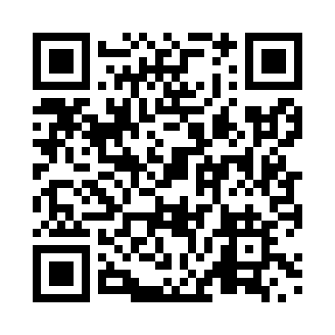
Prayer times for Brule, Alberta, Canada
Wed 1 May 2024 - Fri 31 May 2024
High Latitude Method: Angle Based Rule
Prayer Calculation Method: Islamic Society of North America
Asar Calculation Method: Hanafi

Date | Day | Fajr | Sunrise | Dhuhr | Asr | Maghrib | Isha
1 | Wed | 4:10 | 6:16 | 1:48 | 6:58 | 9:22 | 11:29
2 | Thu | 4:06 | 6:14 | 1:48 | 6:59 | 9:24 | 11:32
3 | Fri | 4:03 | 6:12 | 1:48 | 7:00 | 9:25 | 11:35
4 | Sat | 4:00 | 6:10 | 1:48 | 7:01 | 9:27 | 11:38
5 | Sun | 3:58 | 6:08 | 1:48 | 7:02 | 9:29 | 11:39
6 | Mon | 3:57 | 6:06 | 1:48 | 7:03 | 9:31 | 11:40
7 | Tue | 3:56 | 6:04 | 1:48 | 7:04 | 9:32 | 11:40
8 | Wed | 3:56 | 6:03 | 1:48 | 7:06 | 9:34 | 11:41
9 | Thu | 3:55 | 6:01 | 1:48 | 7:07 | 9:36 | 11:42
10 | Fri | 3:54 | 5:59 | 1:48 | 7:08 | 9:38 | 11:43
11 | Sat | 3:53 | 5:57 | 1:48 | 7:09 | 9:39 | 11:44
12 | Sun | 3:52 | 5:56 | 1:48 | 7:10 | 9:41 | 11:45
13 | Mon | 3:51 | 5:54 | 1:48 | 7:10 | 9:43 | 11:45
14 | Tue | 3:50 | 5:52 | 1:48 | 7:11 | 9:44 | 11:46
15 | Wed | 3:49 | 5:51 | 1:48 | 7:12 | 9:46 | 11:47
16 | Thu | 3:49 | 5:49 | 1:48 | 7:13 | 9:47 | 11:48
17 | Fri | 3:48 | 5:48 | 1:48 | 7:14 | 9:49 | 11:49
18 | Sat | 3:47 | 5:46 | 1:48 | 7:15 | 9:51 | 11:49
19 | Sun | 3:47 | 5:45 | 1:48 | 7:16 | 9:52 | 11:50
20 | Mon | 3:46 | 5:43 | 1:48 | 7:17 | 9:54 | 11:51
21 | Tue | 3:45 | 5:42 | 1:48 | 7:18 | 9:55 | 11:52
22 | Wed | 3:45 | 5:41 | 1:48 | 7:19 | 9:57 | 11:53
23 | Thu | 3:44 | 5:39 | 1:48 | 7:20 | 9:58 | 11:53
24 | Fri | 3:43 | 5:38 | 1:48 | 7:20 | 9:59 | 11:54
25 | Sat | 3:43 | 5:37 | 1:49 | 7:21 | 10:01 | 11:55
26 | Sun | 3:42 | 5:36 | 1:49 | 7:22 | 10:02 | 11:56
27 | Mon | 3:42 | 5:35 | 1:49 | 7:23 | 10:04 | 11:56
28 | Tue | 3:41 | 5:33 | 1:49 | 7:23 | 10:05 | 11:57
29 | Wed | 3:41 | 5:32 | 1:49 | 7:24 | 10:06 | 11:58
30 | Thu | 3:40 | 5:32 | 1:49 | 7:25 | 10:07 | 11:58
31 | Fri | 3:40 | 5:31 | 1:49 | 7:26 | 10:09 | 11:59
Prayer times provided by https://www.salahtimes.com

