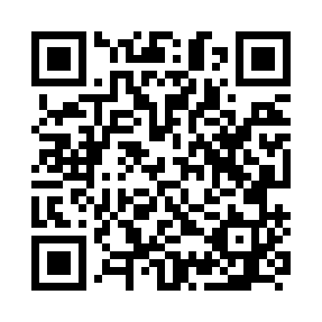
Prayer times for Bilossi, Cameroon
Wed 1 May 2024 - Fri 31 May 2024
High Latitude Method: None
Prayer Calculation Method: Muslim World League
Asar Calculation Method: Shafi

Date | Day | Fajr | Sunrise | Dhuhr | Asr | Maghrib | Isha
1 | Wed | 4:54 | 6:05 | 12:11 | 3:31 | 6:17 | 7:25
2 | Thu | 4:53 | 6:05 | 12:11 | 3:31 | 6:17 | 7:25
3 | Fri | 4:53 | 6:05 | 12:11 | 3:31 | 6:17 | 7:25
4 | Sat | 4:53 | 6:05 | 12:11 | 3:32 | 6:17 | 7:25
5 | Sun | 4:53 | 6:05 | 12:11 | 3:32 | 6:17 | 7:25
6 | Mon | 4:52 | 6:04 | 12:11 | 3:32 | 6:17 | 7:25
7 | Tue | 4:52 | 6:04 | 12:11 | 3:32 | 6:17 | 7:25
8 | Wed | 4:52 | 6:04 | 12:11 | 3:32 | 6:17 | 7:25
9 | Thu | 4:52 | 6:04 | 12:11 | 3:33 | 6:17 | 7:25
10 | Fri | 4:52 | 6:04 | 12:11 | 3:33 | 6:17 | 7:25
11 | Sat | 4:51 | 6:04 | 12:11 | 3:33 | 6:17 | 7:25
12 | Sun | 4:51 | 6:04 | 12:10 | 3:33 | 6:17 | 7:26
13 | Mon | 4:51 | 6:04 | 12:10 | 3:33 | 6:17 | 7:26
14 | Tue | 4:51 | 6:04 | 12:10 | 3:34 | 6:17 | 7:26
15 | Wed | 4:51 | 6:04 | 12:11 | 3:34 | 6:17 | 7:26
16 | Thu | 4:51 | 6:04 | 12:11 | 3:34 | 6:17 | 7:26
17 | Fri | 4:50 | 6:04 | 12:11 | 3:34 | 6:17 | 7:26
18 | Sat | 4:50 | 6:04 | 12:11 | 3:35 | 6:18 | 7:27
19 | Sun | 4:50 | 6:04 | 12:11 | 3:35 | 6:18 | 7:27
20 | Mon | 4:50 | 6:04 | 12:11 | 3:35 | 6:18 | 7:27
21 | Tue | 4:50 | 6:04 | 12:11 | 3:35 | 6:18 | 7:27
22 | Wed | 4:50 | 6:04 | 12:11 | 3:35 | 6:18 | 7:27
23 | Thu | 4:50 | 6:04 | 12:11 | 3:36 | 6:18 | 7:28
24 | Fri | 4:50 | 6:04 | 12:11 | 3:36 | 6:18 | 7:28
25 | Sat | 4:50 | 6:04 | 12:11 | 3:36 | 6:18 | 7:28
26 | Sun | 4:50 | 6:04 | 12:11 | 3:36 | 6:18 | 7:28
27 | Mon | 4:50 | 6:04 | 12:11 | 3:37 | 6:19 | 7:29
28 | Tue | 4:50 | 6:04 | 12:11 | 3:37 | 6:19 | 7:29
29 | Wed | 4:50 | 6:04 | 12:12 | 3:37 | 6:19 | 7:29
30 | Thu | 4:50 | 6:04 | 12:12 | 3:37 | 6:19 | 7:29
31 | Fri | 4:50 | 6:05 | 12:12 | 3:38 | 6:19 | 7:30
Prayer times provided by https://www.salahtimes.com

