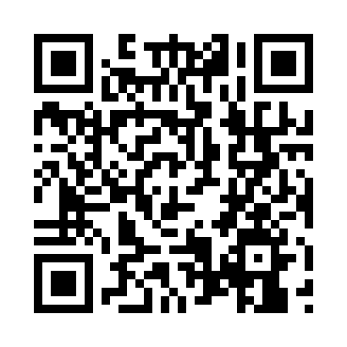
Prayer times for Etbos, Belgium
Wed 1 May 2024 - Fri 31 May 2024
High Latitude Method: Angle Based Rule
Prayer Calculation Method: Muslim World League
Asar Calculation Method: Shafi

Date | Day | Fajr | Sunrise | Dhuhr | Asr | Maghrib | Isha
1 | Wed | 3:49 | 6:16 | 1:41 | 5:44 | 9:07 | 11:24
2 | Thu | 3:46 | 6:15 | 1:41 | 5:45 | 9:09 | 11:27
3 | Fri | 3:42 | 6:13 | 1:41 | 5:45 | 9:10 | 11:30
4 | Sat | 3:39 | 6:11 | 1:41 | 5:46 | 9:12 | 11:33
5 | Sun | 3:35 | 6:09 | 1:41 | 5:47 | 9:13 | 11:36
6 | Mon | 3:31 | 6:08 | 1:41 | 5:47 | 9:15 | 11:39
7 | Tue | 3:28 | 6:06 | 1:41 | 5:48 | 9:17 | 11:42
8 | Wed | 3:26 | 6:04 | 1:41 | 5:48 | 9:18 | 11:46
9 | Thu | 3:26 | 6:02 | 1:41 | 5:49 | 9:20 | 11:48
10 | Fri | 3:25 | 6:01 | 1:41 | 5:50 | 9:21 | 11:48
11 | Sat | 3:24 | 5:59 | 1:41 | 5:50 | 9:23 | 11:49
12 | Sun | 3:24 | 5:58 | 1:41 | 5:51 | 9:24 | 11:50
13 | Mon | 3:23 | 5:56 | 1:41 | 5:51 | 9:26 | 11:50
14 | Tue | 3:22 | 5:55 | 1:41 | 5:52 | 9:27 | 11:51
15 | Wed | 3:22 | 5:53 | 1:41 | 5:53 | 9:29 | 11:52
16 | Thu | 3:21 | 5:52 | 1:41 | 5:53 | 9:30 | 11:52
17 | Fri | 3:21 | 5:50 | 1:41 | 5:54 | 9:32 | 11:53
18 | Sat | 3:20 | 5:49 | 1:41 | 5:54 | 9:33 | 11:54
19 | Sun | 3:20 | 5:48 | 1:41 | 5:55 | 9:35 | 11:54
20 | Mon | 3:19 | 5:46 | 1:41 | 5:55 | 9:36 | 11:55
21 | Tue | 3:19 | 5:45 | 1:41 | 5:56 | 9:37 | 11:56
22 | Wed | 3:18 | 5:44 | 1:41 | 5:56 | 9:39 | 11:56
23 | Thu | 3:18 | 5:43 | 1:41 | 5:57 | 9:40 | 11:57
24 | Fri | 3:18 | 5:42 | 1:41 | 5:58 | 9:41 | 11:57
25 | Sat | 3:17 | 5:41 | 1:41 | 5:58 | 9:43 | 11:58
26 | Sun | 3:17 | 5:40 | 1:41 | 5:59 | 9:44 | 11:59
27 | Mon | 3:16 | 5:39 | 1:42 | 5:59 | 9:45 | 11:59
28 | Tue | 3:16 | 5:38 | 1:42 | 6:00 | 9:46 | 12:00
29 | Wed | 3:16 | 5:37 | 1:42 | 6:00 | 9:47 | 12:00
30 | Thu | 3:16 | 5:36 | 1:42 | 6:00 | 9:48 | 12:01
31 | Fri | 3:15 | 5:35 | 1:42 | 6:01 | 9:50 | 12:01
Prayer times provided by https://www.salahtimes.com

