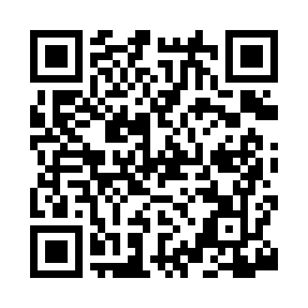
Prayer times for San Antonio, Texas, USA
Wed 1 May 2024 - Fri 31 May 2024
High Latitude Method: Angle Based Rule
Prayer Calculation Method: Islamic Society of North America
Asar Calculation Method: Shafi

Date | Day | Fajr | Sunrise | Dhuhr | Asr | Maghrib | Isha
1 | Wed | 5:41 | 6:51 | 1:31 | 5:07 | 8:11 | 9:22
2 | Thu | 5:40 | 6:51 | 1:31 | 5:07 | 8:12 | 9:22
3 | Fri | 5:39 | 6:50 | 1:31 | 5:07 | 8:12 | 9:23
4 | Sat | 5:38 | 6:49 | 1:31 | 5:07 | 8:13 | 9:24
5 | Sun | 5:37 | 6:48 | 1:31 | 5:06 | 8:13 | 9:25
6 | Mon | 5:36 | 6:47 | 1:31 | 5:06 | 8:14 | 9:26
7 | Tue | 5:35 | 6:47 | 1:31 | 5:06 | 8:15 | 9:27
8 | Wed | 5:34 | 6:46 | 1:30 | 5:06 | 8:15 | 9:27
9 | Thu | 5:33 | 6:45 | 1:30 | 5:06 | 8:16 | 9:28
10 | Fri | 5:32 | 6:45 | 1:30 | 5:06 | 8:17 | 9:29
11 | Sat | 5:31 | 6:44 | 1:30 | 5:06 | 8:17 | 9:30
12 | Sun | 5:30 | 6:43 | 1:30 | 5:06 | 8:18 | 9:31
13 | Mon | 5:30 | 6:43 | 1:30 | 5:06 | 8:18 | 9:32
14 | Tue | 5:29 | 6:42 | 1:30 | 5:06 | 8:19 | 9:32
15 | Wed | 5:28 | 6:41 | 1:30 | 5:06 | 8:20 | 9:33
16 | Thu | 5:27 | 6:41 | 1:30 | 5:06 | 8:20 | 9:34
17 | Fri | 5:26 | 6:40 | 1:30 | 5:06 | 8:21 | 9:35
18 | Sat | 5:26 | 6:40 | 1:30 | 5:06 | 8:22 | 9:36
19 | Sun | 5:25 | 6:39 | 1:31 | 5:06 | 8:22 | 9:36
20 | Mon | 5:24 | 6:39 | 1:31 | 5:06 | 8:23 | 9:37
21 | Tue | 5:24 | 6:38 | 1:31 | 5:06 | 8:23 | 9:38
22 | Wed | 5:23 | 6:38 | 1:31 | 5:06 | 8:24 | 9:39
23 | Thu | 5:23 | 6:37 | 1:31 | 5:06 | 8:25 | 9:40
24 | Fri | 5:22 | 6:37 | 1:31 | 5:06 | 8:25 | 9:40
25 | Sat | 5:21 | 6:37 | 1:31 | 5:06 | 8:26 | 9:41
26 | Sun | 5:21 | 6:36 | 1:31 | 5:06 | 8:26 | 9:42
27 | Mon | 5:20 | 6:36 | 1:31 | 5:06 | 8:27 | 9:42
28 | Tue | 5:20 | 6:36 | 1:31 | 5:06 | 8:27 | 9:43
29 | Wed | 5:19 | 6:35 | 1:32 | 5:06 | 8:28 | 9:44
30 | Thu | 5:19 | 6:35 | 1:32 | 5:06 | 8:29 | 9:45
31 | Fri | 5:19 | 6:35 | 1:32 | 5:06 | 8:29 | 9:45
Prayer times provided by https://www.salahtimes.com

