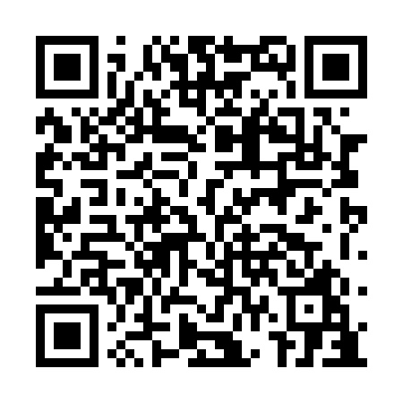
Prayer times for Amethyst Harbour, Ontario, Canada
Wed 1 May 2024 - Fri 31 May 2024
High Latitude Method: Angle Based Rule
Prayer Calculation Method: Islamic Society of North America
Asar Calculation Method: Hanafi

Date | Day | Fajr | Sunrise | Dhuhr | Asr | Maghrib | Isha
1 | Wed | 4:50 | 6:35 | 1:53 | 6:57 | 9:11 | 10:56
2 | Thu | 4:48 | 6:33 | 1:52 | 6:58 | 9:12 | 10:58
3 | Fri | 4:45 | 6:32 | 1:52 | 6:59 | 9:14 | 11:01
4 | Sat | 4:43 | 6:30 | 1:52 | 6:59 | 9:15 | 11:03
5 | Sun | 4:41 | 6:28 | 1:52 | 7:00 | 9:17 | 11:05
6 | Mon | 4:38 | 6:27 | 1:52 | 7:01 | 9:18 | 11:07
7 | Tue | 4:36 | 6:25 | 1:52 | 7:02 | 9:20 | 11:09
8 | Wed | 4:34 | 6:24 | 1:52 | 7:03 | 9:21 | 11:12
9 | Thu | 4:31 | 6:22 | 1:52 | 7:04 | 9:22 | 11:14
10 | Fri | 4:29 | 6:21 | 1:52 | 7:04 | 9:24 | 11:16
11 | Sat | 4:27 | 6:19 | 1:52 | 7:05 | 9:25 | 11:18
12 | Sun | 4:24 | 6:18 | 1:52 | 7:06 | 9:26 | 11:21
13 | Mon | 4:22 | 6:17 | 1:52 | 7:07 | 9:28 | 11:23
14 | Tue | 4:20 | 6:15 | 1:52 | 7:08 | 9:29 | 11:25
15 | Wed | 4:18 | 6:14 | 1:52 | 7:08 | 9:30 | 11:27
16 | Thu | 4:16 | 6:13 | 1:52 | 7:09 | 9:32 | 11:29
17 | Fri | 4:13 | 6:12 | 1:52 | 7:10 | 9:33 | 11:32
18 | Sat | 4:11 | 6:10 | 1:52 | 7:11 | 9:34 | 11:34
19 | Sun | 4:09 | 6:09 | 1:52 | 7:11 | 9:35 | 11:36
20 | Mon | 4:07 | 6:08 | 1:52 | 7:12 | 9:37 | 11:38
21 | Tue | 4:05 | 6:07 | 1:52 | 7:13 | 9:38 | 11:40
22 | Wed | 4:03 | 6:06 | 1:52 | 7:14 | 9:39 | 11:42
23 | Thu | 4:01 | 6:05 | 1:52 | 7:14 | 9:40 | 11:45
24 | Fri | 3:59 | 6:04 | 1:52 | 7:15 | 9:41 | 11:47
25 | Sat | 3:58 | 6:03 | 1:53 | 7:16 | 9:43 | 11:48
26 | Sun | 3:57 | 6:02 | 1:53 | 7:16 | 9:44 | 11:48
27 | Mon | 3:57 | 6:01 | 1:53 | 7:17 | 9:45 | 11:49
28 | Tue | 3:57 | 6:00 | 1:53 | 7:18 | 9:46 | 11:49
29 | Wed | 3:56 | 6:00 | 1:53 | 7:18 | 9:47 | 11:50
30 | Thu | 3:56 | 5:59 | 1:53 | 7:19 | 9:48 | 11:51
31 | Fri | 3:56 | 5:58 | 1:53 | 7:20 | 9:49 | 11:51
Prayer times provided by https://www.salahtimes.com

