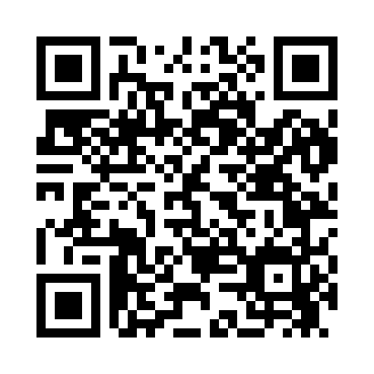
Prayer times for Adirondack, New York, USA
Wed 1 May 2024 - Fri 31 May 2024
High Latitude Method: Angle Based Rule
Prayer Calculation Method: Islamic Society of North America
Asar Calculation Method: Shafi

Date | Day | Fajr | Sunrise | Dhuhr | Asr | Maghrib | Isha
1 | Wed | 4:15 | 5:46 | 12:52 | 4:47 | 7:58 | 9:30
2 | Thu | 4:13 | 5:45 | 12:52 | 4:48 | 8:00 | 9:32
3 | Fri | 4:11 | 5:44 | 12:52 | 4:48 | 8:01 | 9:33
4 | Sat | 4:09 | 5:42 | 12:52 | 4:48 | 8:02 | 9:35
5 | Sun | 4:08 | 5:41 | 12:52 | 4:49 | 8:03 | 9:37
6 | Mon | 4:06 | 5:40 | 12:52 | 4:49 | 8:04 | 9:38
7 | Tue | 4:04 | 5:38 | 12:52 | 4:49 | 8:05 | 9:40
8 | Wed | 4:02 | 5:37 | 12:52 | 4:50 | 8:07 | 9:42
9 | Thu | 4:01 | 5:36 | 12:51 | 4:50 | 8:08 | 9:43
10 | Fri | 3:59 | 5:35 | 12:51 | 4:50 | 8:09 | 9:45
11 | Sat | 3:57 | 5:33 | 12:51 | 4:51 | 8:10 | 9:47
12 | Sun | 3:55 | 5:32 | 12:51 | 4:51 | 8:11 | 9:48
13 | Mon | 3:54 | 5:31 | 12:51 | 4:52 | 8:12 | 9:50
14 | Tue | 3:52 | 5:30 | 12:51 | 4:52 | 8:13 | 9:51
15 | Wed | 3:51 | 5:29 | 12:51 | 4:52 | 8:14 | 9:53
16 | Thu | 3:49 | 5:28 | 12:51 | 4:53 | 8:15 | 9:55
17 | Fri | 3:48 | 5:27 | 12:51 | 4:53 | 8:16 | 9:56
18 | Sat | 3:46 | 5:26 | 12:52 | 4:53 | 8:18 | 9:58
19 | Sun | 3:45 | 5:25 | 12:52 | 4:54 | 8:19 | 9:59
20 | Mon | 3:43 | 5:24 | 12:52 | 4:54 | 8:20 | 10:01
21 | Tue | 3:42 | 5:23 | 12:52 | 4:54 | 8:21 | 10:02
22 | Wed | 3:40 | 5:22 | 12:52 | 4:55 | 8:22 | 10:04
23 | Thu | 3:39 | 5:22 | 12:52 | 4:55 | 8:23 | 10:05
24 | Fri | 3:38 | 5:21 | 12:52 | 4:55 | 8:24 | 10:07
25 | Sat | 3:37 | 5:20 | 12:52 | 4:56 | 8:25 | 10:08
26 | Sun | 3:35 | 5:19 | 12:52 | 4:56 | 8:25 | 10:10
27 | Mon | 3:34 | 5:19 | 12:52 | 4:56 | 8:26 | 10:11
28 | Tue | 3:33 | 5:18 | 12:52 | 4:57 | 8:27 | 10:12
29 | Wed | 3:32 | 5:17 | 12:53 | 4:57 | 8:28 | 10:14
30 | Thu | 3:31 | 5:17 | 12:53 | 4:57 | 8:29 | 10:15
31 | Fri | 3:30 | 5:16 | 12:53 | 4:58 | 8:30 | 10:16
Prayer times provided by https://www.salahtimes.com

