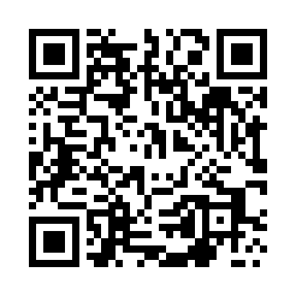
Prayer times for Slowikowo, Poland
Mon 1 Apr 2024 - Tue 30 Apr 2024
High Latitude Method: Angle Based Rule
Prayer Calculation Method: Muslim World League
Asar Calculation Method: Hanafi

Date | Day | Fajr | Sunrise | Dhuhr | Asr | Maghrib | Isha
1 | Mon | 4:20 | 6:22 | 12:52 | 5:19 | 7:23 | 9:18
2 | Tue | 4:17 | 6:19 | 12:52 | 5:20 | 7:25 | 9:20
3 | Wed | 4:14 | 6:17 | 12:51 | 5:21 | 7:27 | 9:22
4 | Thu | 4:11 | 6:15 | 12:51 | 5:22 | 7:28 | 9:25
5 | Fri | 4:08 | 6:12 | 12:51 | 5:24 | 7:30 | 9:27
6 | Sat | 4:05 | 6:10 | 12:51 | 5:25 | 7:32 | 9:30
7 | Sun | 4:02 | 6:08 | 12:50 | 5:26 | 7:34 | 9:32
8 | Mon | 3:58 | 6:06 | 12:50 | 5:27 | 7:35 | 9:34
9 | Tue | 3:55 | 6:03 | 12:50 | 5:29 | 7:37 | 9:37
10 | Wed | 3:52 | 6:01 | 12:49 | 5:30 | 7:39 | 9:39
11 | Thu | 3:49 | 5:59 | 12:49 | 5:31 | 7:41 | 9:42
12 | Fri | 3:46 | 5:56 | 12:49 | 5:32 | 7:42 | 9:45
13 | Sat | 3:43 | 5:54 | 12:49 | 5:33 | 7:44 | 9:47
14 | Sun | 3:39 | 5:52 | 12:48 | 5:35 | 7:46 | 9:50
15 | Mon | 3:36 | 5:50 | 12:48 | 5:36 | 7:48 | 9:53
16 | Tue | 3:33 | 5:47 | 12:48 | 5:37 | 7:49 | 9:55
17 | Wed | 3:29 | 5:45 | 12:48 | 5:38 | 7:51 | 9:58
18 | Thu | 3:26 | 5:43 | 12:47 | 5:39 | 7:53 | 10:01
19 | Fri | 3:23 | 5:41 | 12:47 | 5:40 | 7:55 | 10:04
20 | Sat | 3:19 | 5:39 | 12:47 | 5:42 | 7:56 | 10:07
21 | Sun | 3:16 | 5:37 | 12:47 | 5:43 | 7:58 | 10:09
22 | Mon | 3:12 | 5:34 | 12:47 | 5:44 | 8:00 | 10:12
23 | Tue | 3:09 | 5:32 | 12:46 | 5:45 | 8:02 | 10:15
24 | Wed | 3:05 | 5:30 | 12:46 | 5:46 | 8:03 | 10:18
25 | Thu | 3:01 | 5:28 | 12:46 | 5:47 | 8:05 | 10:21
26 | Fri | 2:58 | 5:26 | 12:46 | 5:48 | 8:07 | 10:25
27 | Sat | 2:54 | 5:24 | 12:46 | 5:49 | 8:09 | 10:28
28 | Sun | 2:50 | 5:22 | 12:46 | 5:50 | 8:10 | 10:31
29 | Mon | 2:46 | 5:20 | 12:46 | 5:52 | 8:12 | 10:34
30 | Tue | 2:42 | 5:18 | 12:45 | 5:53 | 8:14 | 10:38
Prayer times provided by https://www.salahtimes.com

