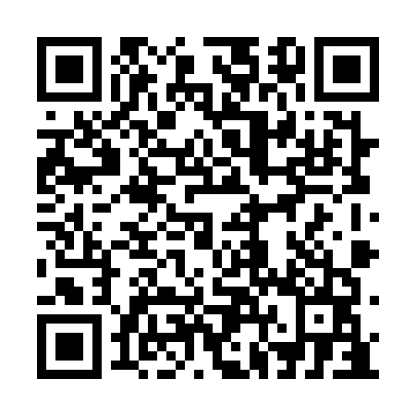
Prayer times for Saint-Zenon-du-Lac-Humqui, Quebec, Canada
Mon 1 Jul 2024 - Wed 31 Jul 2024
High Latitude Method: Angle Based Rule
Prayer Calculation Method: Islamic Society of North America
Asar Calculation Method: Hanafi

Date | Day | Fajr | Sunrise | Dhuhr | Asr | Maghrib | Isha
1 | Mon | 2:34 | 4:34 | 12:34 | 6:03 | 8:35 | 10:34
2 | Tue | 2:35 | 4:35 | 12:35 | 6:03 | 8:34 | 10:34
3 | Wed | 2:35 | 4:35 | 12:35 | 6:03 | 8:34 | 10:34
4 | Thu | 2:35 | 4:36 | 12:35 | 6:03 | 8:34 | 10:34
5 | Fri | 2:36 | 4:37 | 12:35 | 6:03 | 8:33 | 10:34
6 | Sat | 2:36 | 4:38 | 12:35 | 6:03 | 8:33 | 10:34
7 | Sun | 2:37 | 4:38 | 12:35 | 6:02 | 8:32 | 10:34
8 | Mon | 2:37 | 4:39 | 12:36 | 6:02 | 8:32 | 10:33
9 | Tue | 2:38 | 4:40 | 12:36 | 6:02 | 8:31 | 10:33
10 | Wed | 2:38 | 4:41 | 12:36 | 6:02 | 8:30 | 10:33
11 | Thu | 2:39 | 4:42 | 12:36 | 6:01 | 8:30 | 10:33
12 | Fri | 2:39 | 4:43 | 12:36 | 6:01 | 8:29 | 10:32
13 | Sat | 2:40 | 4:44 | 12:36 | 6:01 | 8:28 | 10:32
14 | Sun | 2:41 | 4:45 | 12:36 | 6:00 | 8:27 | 10:32
15 | Mon | 2:41 | 4:46 | 12:36 | 6:00 | 8:26 | 10:31
16 | Tue | 2:42 | 4:47 | 12:37 | 5:59 | 8:25 | 10:30
17 | Wed | 2:44 | 4:48 | 12:37 | 5:59 | 8:25 | 10:28
18 | Thu | 2:46 | 4:49 | 12:37 | 5:58 | 8:24 | 10:26
19 | Fri | 2:48 | 4:50 | 12:37 | 5:58 | 8:23 | 10:24
20 | Sat | 2:50 | 4:51 | 12:37 | 5:57 | 8:22 | 10:22
21 | Sun | 2:52 | 4:53 | 12:37 | 5:57 | 8:20 | 10:20
22 | Mon | 2:54 | 4:54 | 12:37 | 5:56 | 8:19 | 10:18
23 | Tue | 2:56 | 4:55 | 12:37 | 5:55 | 8:18 | 10:16
24 | Wed | 2:58 | 4:56 | 12:37 | 5:55 | 8:17 | 10:14
25 | Thu | 3:00 | 4:57 | 12:37 | 5:54 | 8:16 | 10:12
26 | Fri | 3:03 | 4:59 | 12:37 | 5:53 | 8:14 | 10:10
27 | Sat | 3:05 | 5:00 | 12:37 | 5:53 | 8:13 | 10:08
28 | Sun | 3:07 | 5:01 | 12:37 | 5:52 | 8:12 | 10:06
29 | Mon | 3:09 | 5:02 | 12:37 | 5:51 | 8:10 | 10:04
30 | Tue | 3:11 | 5:04 | 12:37 | 5:50 | 8:09 | 10:01
31 | Wed | 3:13 | 5:05 | 12:37 | 5:49 | 8:08 | 9:59
Prayer times provided by https://www.salahtimes.com

