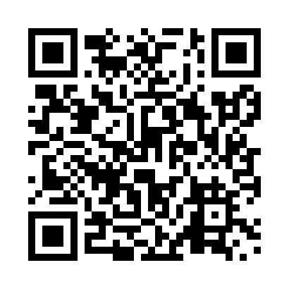
Prayer times for Abana, Quebec, Canada
Sat 1 Jun 2024 - Sun 30 Jun 2024
High Latitude Method: Angle Based Rule
Prayer Calculation Method: Islamic Society of North America
Asar Calculation Method: Hanafi

Date | Day | Fajr | Sunrise | Dhuhr | Asr | Maghrib | Isha
1 | Sat | 3:17 | 5:18 | 1:15 | 6:43 | 9:14 | 11:15
2 | Sun | 3:16 | 5:17 | 1:15 | 6:43 | 9:14 | 11:15
3 | Mon | 3:16 | 5:16 | 1:16 | 6:44 | 9:15 | 11:16
4 | Tue | 3:16 | 5:16 | 1:16 | 6:44 | 9:16 | 11:16
5 | Wed | 3:16 | 5:15 | 1:16 | 6:45 | 9:17 | 11:17
6 | Thu | 3:16 | 5:15 | 1:16 | 6:46 | 9:18 | 11:17
7 | Fri | 3:15 | 5:14 | 1:16 | 6:46 | 9:19 | 11:18
8 | Sat | 3:15 | 5:14 | 1:17 | 6:47 | 9:19 | 11:18
9 | Sun | 3:15 | 5:14 | 1:17 | 6:47 | 9:20 | 11:18
10 | Mon | 3:15 | 5:13 | 1:17 | 6:47 | 9:21 | 11:19
11 | Tue | 3:15 | 5:13 | 1:17 | 6:48 | 9:21 | 11:19
12 | Wed | 3:15 | 5:13 | 1:17 | 6:48 | 9:22 | 11:20
13 | Thu | 3:15 | 5:13 | 1:18 | 6:49 | 9:22 | 11:20
14 | Fri | 3:15 | 5:13 | 1:18 | 6:49 | 9:23 | 11:20
15 | Sat | 3:15 | 5:13 | 1:18 | 6:49 | 9:23 | 11:21
16 | Sun | 3:16 | 5:13 | 1:18 | 6:50 | 9:24 | 11:21
17 | Mon | 3:16 | 5:13 | 1:18 | 6:50 | 9:24 | 11:21
18 | Tue | 3:16 | 5:13 | 1:19 | 6:50 | 9:24 | 11:22
19 | Wed | 3:16 | 5:13 | 1:19 | 6:51 | 9:25 | 11:22
20 | Thu | 3:16 | 5:13 | 1:19 | 6:51 | 9:25 | 11:22
21 | Fri | 3:16 | 5:13 | 1:19 | 6:51 | 9:25 | 11:22
22 | Sat | 3:17 | 5:14 | 1:20 | 6:51 | 9:25 | 11:22
23 | Sun | 3:17 | 5:14 | 1:20 | 6:51 | 9:25 | 11:23
24 | Mon | 3:17 | 5:14 | 1:20 | 6:51 | 9:25 | 11:23
25 | Tue | 3:17 | 5:15 | 1:20 | 6:52 | 9:26 | 11:23
26 | Wed | 3:18 | 5:15 | 1:20 | 6:52 | 9:25 | 11:23
27 | Thu | 3:18 | 5:16 | 1:21 | 6:52 | 9:25 | 11:23
28 | Fri | 3:18 | 5:16 | 1:21 | 6:52 | 9:25 | 11:23
29 | Sat | 3:19 | 5:17 | 1:21 | 6:52 | 9:25 | 11:23
30 | Sun | 3:19 | 5:17 | 1:21 | 6:52 | 9:25 | 11:23
Prayer times provided by https://www.salahtimes.com

