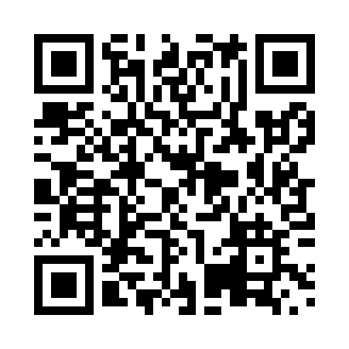
Prayer times for Toney Mills, Nova Scotia, Canada
Mon 1 Apr 2024 - Tue 30 Apr 2024
High Latitude Method: Angle Based Rule
Prayer Calculation Method: Islamic Society of North America
Asar Calculation Method: Hanafi

Date | Day | Fajr | Sunrise | Dhuhr | Asr | Maghrib | Isha
1 | Mon | 5:26 | 6:51 | 1:15 | 5:45 | 7:41 | 9:05
2 | Tue | 5:24 | 6:49 | 1:15 | 5:45 | 7:42 | 9:07
3 | Wed | 5:22 | 6:47 | 1:15 | 5:46 | 7:43 | 9:09
4 | Thu | 5:20 | 6:45 | 1:14 | 5:47 | 7:45 | 9:10
5 | Fri | 5:18 | 6:43 | 1:14 | 5:48 | 7:46 | 9:12
6 | Sat | 5:15 | 6:41 | 1:14 | 5:49 | 7:47 | 9:13
7 | Sun | 5:13 | 6:39 | 1:14 | 5:50 | 7:49 | 9:15
8 | Mon | 5:11 | 6:38 | 1:13 | 5:51 | 7:50 | 9:16
9 | Tue | 5:09 | 6:36 | 1:13 | 5:52 | 7:51 | 9:18
10 | Wed | 5:07 | 6:34 | 1:13 | 5:53 | 7:52 | 9:20
11 | Thu | 5:05 | 6:32 | 1:13 | 5:54 | 7:54 | 9:21
12 | Fri | 5:02 | 6:30 | 1:12 | 5:54 | 7:55 | 9:23
13 | Sat | 5:00 | 6:28 | 1:12 | 5:55 | 7:56 | 9:25
14 | Sun | 4:58 | 6:27 | 1:12 | 5:56 | 7:58 | 9:26
15 | Mon | 4:56 | 6:25 | 1:12 | 5:57 | 7:59 | 9:28
16 | Tue | 4:54 | 6:23 | 1:11 | 5:58 | 8:00 | 9:30
17 | Wed | 4:52 | 6:21 | 1:11 | 5:59 | 8:02 | 9:32
18 | Thu | 4:49 | 6:20 | 1:11 | 5:59 | 8:03 | 9:33
19 | Fri | 4:47 | 6:18 | 1:11 | 6:00 | 8:04 | 9:35
20 | Sat | 4:45 | 6:16 | 1:10 | 6:01 | 8:05 | 9:37
21 | Sun | 4:43 | 6:14 | 1:10 | 6:02 | 8:07 | 9:38
22 | Mon | 4:41 | 6:13 | 1:10 | 6:03 | 8:08 | 9:40
23 | Tue | 4:39 | 6:11 | 1:10 | 6:04 | 8:09 | 9:42
24 | Wed | 4:37 | 6:09 | 1:10 | 6:04 | 8:11 | 9:44
25 | Thu | 4:34 | 6:08 | 1:09 | 6:05 | 8:12 | 9:46
26 | Fri | 4:32 | 6:06 | 1:09 | 6:06 | 8:13 | 9:47
27 | Sat | 4:30 | 6:05 | 1:09 | 6:07 | 8:15 | 9:49
28 | Sun | 4:28 | 6:03 | 1:09 | 6:08 | 8:16 | 9:51
29 | Mon | 4:26 | 6:01 | 1:09 | 6:08 | 8:17 | 9:53
30 | Tue | 4:24 | 6:00 | 1:09 | 6:09 | 8:18 | 9:55
Prayer times provided by https://www.salahtimes.com

