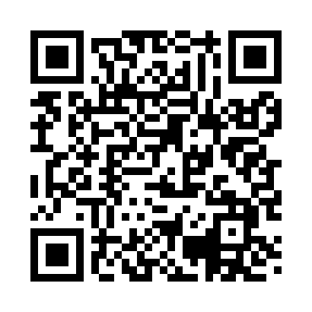
Prayer times for Crawford Fork, Alabama, USA
Wed 1 May 2024 - Fri 31 May 2024
High Latitude Method: Angle Based Rule
Prayer Calculation Method: Islamic Society of North America
Asar Calculation Method: Shafi

Date | Day | Fajr | Sunrise | Dhuhr | Asr | Maghrib | Isha
1 | Wed | 4:50 | 6:04 | 12:49 | 4:30 | 7:34 | 8:49
2 | Thu | 4:49 | 6:03 | 12:49 | 4:30 | 7:35 | 8:50
3 | Fri | 4:48 | 6:03 | 12:49 | 4:30 | 7:36 | 8:51
4 | Sat | 4:47 | 6:02 | 12:49 | 4:30 | 7:37 | 8:52
5 | Sun | 4:46 | 6:01 | 12:49 | 4:30 | 7:37 | 8:53
6 | Mon | 4:45 | 6:00 | 12:49 | 4:30 | 7:38 | 8:53
7 | Tue | 4:44 | 5:59 | 12:49 | 4:30 | 7:39 | 8:54
8 | Wed | 4:43 | 5:58 | 12:49 | 4:30 | 7:40 | 8:55
9 | Thu | 4:41 | 5:57 | 12:49 | 4:31 | 7:40 | 8:56
10 | Fri | 4:40 | 5:56 | 12:49 | 4:31 | 7:41 | 8:57
11 | Sat | 4:39 | 5:56 | 12:49 | 4:31 | 7:42 | 8:58
12 | Sun | 4:38 | 5:55 | 12:49 | 4:31 | 7:43 | 8:59
13 | Mon | 4:37 | 5:54 | 12:49 | 4:31 | 7:43 | 9:00
14 | Tue | 4:37 | 5:54 | 12:49 | 4:31 | 7:44 | 9:01
15 | Wed | 4:36 | 5:53 | 12:49 | 4:31 | 7:45 | 9:02
16 | Thu | 4:35 | 5:52 | 12:49 | 4:31 | 7:45 | 9:03
17 | Fri | 4:34 | 5:52 | 12:49 | 4:31 | 7:46 | 9:04
18 | Sat | 4:33 | 5:51 | 12:49 | 4:31 | 7:47 | 9:05
19 | Sun | 4:32 | 5:50 | 12:49 | 4:31 | 7:48 | 9:06
20 | Mon | 4:31 | 5:50 | 12:49 | 4:31 | 7:48 | 9:07
21 | Tue | 4:31 | 5:49 | 12:49 | 4:31 | 7:49 | 9:08
22 | Wed | 4:30 | 5:49 | 12:49 | 4:31 | 7:50 | 9:09
23 | Thu | 4:29 | 5:48 | 12:49 | 4:32 | 7:50 | 9:09
24 | Fri | 4:28 | 5:48 | 12:49 | 4:32 | 7:51 | 9:10
25 | Sat | 4:28 | 5:47 | 12:49 | 4:32 | 7:52 | 9:11
26 | Sun | 4:27 | 5:47 | 12:49 | 4:32 | 7:52 | 9:12
27 | Mon | 4:27 | 5:46 | 12:49 | 4:32 | 7:53 | 9:13
28 | Tue | 4:26 | 5:46 | 12:50 | 4:32 | 7:53 | 9:14
29 | Wed | 4:25 | 5:46 | 12:50 | 4:32 | 7:54 | 9:14
30 | Thu | 4:25 | 5:45 | 12:50 | 4:32 | 7:55 | 9:15
31 | Fri | 4:25 | 5:45 | 12:50 | 4:33 | 7:55 | 9:16
Prayer times provided by https://www.salahtimes.com

