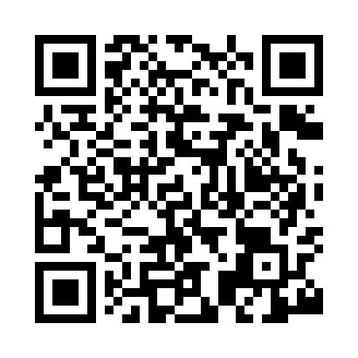
Prayer times for Bloxham, Oxfordshire, UK
Wed 1 May 2024 - Fri 31 May 2024
High Latitude Method: Angle Based Rule
Prayer Calculation Method: Islamic Society of North America
Asar Calculation Method: Hanafi

Date | Day | Fajr | Sunrise | Dhuhr | Asr | Maghrib | Isha
1 | Wed | 3:36 | 5:35 | 1:03 | 6:10 | 8:31 | 10:31
2 | Thu | 3:33 | 5:33 | 1:02 | 6:11 | 8:33 | 10:33
3 | Fri | 3:30 | 5:31 | 1:02 | 6:12 | 8:34 | 10:36
4 | Sat | 3:27 | 5:29 | 1:02 | 6:13 | 8:36 | 10:39
5 | Sun | 3:24 | 5:27 | 1:02 | 6:14 | 8:38 | 10:42
6 | Mon | 3:21 | 5:26 | 1:02 | 6:15 | 8:39 | 10:45
7 | Tue | 3:18 | 5:24 | 1:02 | 6:16 | 8:41 | 10:48
8 | Wed | 3:15 | 5:22 | 1:02 | 6:17 | 8:43 | 10:51
9 | Thu | 3:12 | 5:20 | 1:02 | 6:18 | 8:44 | 10:53
10 | Fri | 3:11 | 5:19 | 1:02 | 6:19 | 8:46 | 10:54
11 | Sat | 3:10 | 5:17 | 1:02 | 6:20 | 8:47 | 10:55
12 | Sun | 3:09 | 5:16 | 1:02 | 6:21 | 8:49 | 10:56
13 | Mon | 3:08 | 5:14 | 1:02 | 6:22 | 8:50 | 10:56
14 | Tue | 3:07 | 5:12 | 1:02 | 6:23 | 8:52 | 10:57
15 | Wed | 3:07 | 5:11 | 1:02 | 6:24 | 8:54 | 10:58
16 | Thu | 3:06 | 5:09 | 1:02 | 6:25 | 8:55 | 10:59
17 | Fri | 3:05 | 5:08 | 1:02 | 6:26 | 8:57 | 10:59
18 | Sat | 3:04 | 5:07 | 1:02 | 6:27 | 8:58 | 11:00
19 | Sun | 3:04 | 5:05 | 1:02 | 6:27 | 9:00 | 11:01
20 | Mon | 3:03 | 5:04 | 1:02 | 6:28 | 9:01 | 11:02
21 | Tue | 3:02 | 5:03 | 1:02 | 6:29 | 9:02 | 11:02
22 | Wed | 3:02 | 5:01 | 1:02 | 6:30 | 9:04 | 11:03
23 | Thu | 3:01 | 5:00 | 1:02 | 6:31 | 9:05 | 11:04
24 | Fri | 3:01 | 4:59 | 1:02 | 6:31 | 9:07 | 11:05
25 | Sat | 3:00 | 4:58 | 1:02 | 6:32 | 9:08 | 11:05
26 | Sun | 3:00 | 4:57 | 1:03 | 6:33 | 9:09 | 11:06
27 | Mon | 2:59 | 4:56 | 1:03 | 6:34 | 9:10 | 11:07
28 | Tue | 2:59 | 4:55 | 1:03 | 6:34 | 9:12 | 11:07
29 | Wed | 2:58 | 4:54 | 1:03 | 6:35 | 9:13 | 11:08
30 | Thu | 2:58 | 4:53 | 1:03 | 6:36 | 9:14 | 11:09
31 | Fri | 2:58 | 4:52 | 1:03 | 6:37 | 9:15 | 11:09
Prayer times provided by https://www.salahtimes.com

