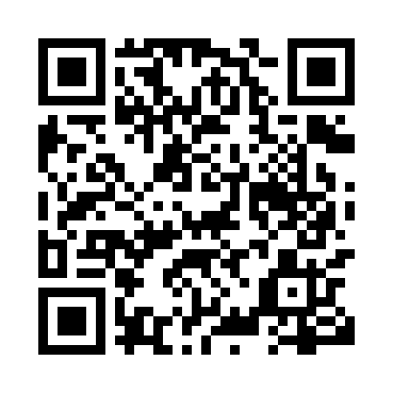
Prayer times for Bourbonnais, Quebec, Canada
Wed 1 May 2024 - Fri 31 May 2024
High Latitude Method: Angle Based Rule
Prayer Calculation Method: Islamic Society of North America
Asar Calculation Method: Hanafi

Date | Day | Fajr | Sunrise | Dhuhr | Asr | Maghrib | Isha
1 | Wed | 3:50 | 5:29 | 12:41 | 5:43 | 7:54 | 9:33
2 | Thu | 3:48 | 5:27 | 12:41 | 5:44 | 7:56 | 9:35
3 | Fri | 3:46 | 5:26 | 12:41 | 5:45 | 7:57 | 9:37
4 | Sat | 3:44 | 5:24 | 12:41 | 5:46 | 7:58 | 9:39
5 | Sun | 3:41 | 5:23 | 12:41 | 5:46 | 8:00 | 9:41
6 | Mon | 3:39 | 5:21 | 12:41 | 5:47 | 8:01 | 9:43
7 | Tue | 3:37 | 5:20 | 12:41 | 5:48 | 8:02 | 9:45
8 | Wed | 3:35 | 5:18 | 12:41 | 5:49 | 8:03 | 9:47
9 | Thu | 3:33 | 5:17 | 12:41 | 5:49 | 8:05 | 9:49
10 | Fri | 3:31 | 5:16 | 12:40 | 5:50 | 8:06 | 9:51
11 | Sat | 3:29 | 5:14 | 12:40 | 5:51 | 8:07 | 9:53
12 | Sun | 3:27 | 5:13 | 12:40 | 5:52 | 8:08 | 9:55
13 | Mon | 3:25 | 5:12 | 12:40 | 5:52 | 8:10 | 9:57
14 | Tue | 3:23 | 5:11 | 12:40 | 5:53 | 8:11 | 9:59
15 | Wed | 3:22 | 5:09 | 12:40 | 5:54 | 8:12 | 10:00
16 | Thu | 3:20 | 5:08 | 12:40 | 5:55 | 8:13 | 10:02
17 | Fri | 3:18 | 5:07 | 12:41 | 5:55 | 8:15 | 10:04
18 | Sat | 3:16 | 5:06 | 12:41 | 5:56 | 8:16 | 10:06
19 | Sun | 3:14 | 5:05 | 12:41 | 5:57 | 8:17 | 10:08
20 | Mon | 3:12 | 5:04 | 12:41 | 5:57 | 8:18 | 10:10
21 | Tue | 3:11 | 5:03 | 12:41 | 5:58 | 8:19 | 10:12
22 | Wed | 3:09 | 5:02 | 12:41 | 5:59 | 8:20 | 10:13
23 | Thu | 3:07 | 5:01 | 12:41 | 5:59 | 8:21 | 10:15
24 | Fri | 3:06 | 5:00 | 12:41 | 6:00 | 8:22 | 10:17
25 | Sat | 3:04 | 4:59 | 12:41 | 6:01 | 8:24 | 10:19
26 | Sun | 3:03 | 4:58 | 12:41 | 6:01 | 8:25 | 10:21
27 | Mon | 3:01 | 4:58 | 12:41 | 6:02 | 8:26 | 10:22
28 | Tue | 3:00 | 4:57 | 12:41 | 6:02 | 8:27 | 10:24
29 | Wed | 2:59 | 4:56 | 12:42 | 6:03 | 8:28 | 10:25
30 | Thu | 2:57 | 4:55 | 12:42 | 6:04 | 8:28 | 10:27
31 | Fri | 2:56 | 4:55 | 12:42 | 6:04 | 8:29 | 10:29
Prayer times provided by https://www.salahtimes.com

