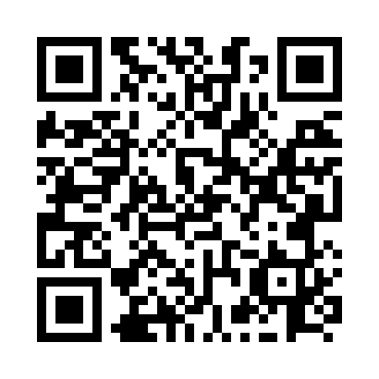
Prayer times for Sibleys Cove, Newfoundland and Labrador, Canada
Mon 1 Jul 2024 - Wed 31 Jul 2024
High Latitude Method: Angle Based Rule
Prayer Calculation Method: Islamic Society of North America
Asar Calculation Method: Hanafi

Date | Day | Fajr | Sunrise | Dhuhr | Asr | Maghrib | Isha
1 | Mon | 3:07 | 5:07 | 1:06 | 6:35 | 9:05 | 11:06
2 | Tue | 3:07 | 5:08 | 1:07 | 6:35 | 9:05 | 11:06
3 | Wed | 3:08 | 5:08 | 1:07 | 6:35 | 9:05 | 11:06
4 | Thu | 3:08 | 5:09 | 1:07 | 6:34 | 9:04 | 11:06
5 | Fri | 3:08 | 5:10 | 1:07 | 6:34 | 9:04 | 11:06
6 | Sat | 3:09 | 5:11 | 1:07 | 6:34 | 9:04 | 11:05
7 | Sun | 3:09 | 5:12 | 1:07 | 6:34 | 9:03 | 11:05
8 | Mon | 3:10 | 5:12 | 1:08 | 6:34 | 9:02 | 11:05
9 | Tue | 3:10 | 5:13 | 1:08 | 6:34 | 9:02 | 11:05
10 | Wed | 3:11 | 5:14 | 1:08 | 6:33 | 9:01 | 11:04
11 | Thu | 3:11 | 5:15 | 1:08 | 6:33 | 9:01 | 11:04
12 | Fri | 3:12 | 5:16 | 1:08 | 6:33 | 9:00 | 11:04
13 | Sat | 3:13 | 5:17 | 1:08 | 6:32 | 8:59 | 11:04
14 | Sun | 3:13 | 5:18 | 1:08 | 6:32 | 8:58 | 11:03
15 | Mon | 3:15 | 5:19 | 1:08 | 6:31 | 8:57 | 11:01
16 | Tue | 3:17 | 5:20 | 1:09 | 6:31 | 8:57 | 11:00
17 | Wed | 3:19 | 5:21 | 1:09 | 6:31 | 8:56 | 10:58
18 | Thu | 3:20 | 5:22 | 1:09 | 6:30 | 8:55 | 10:56
19 | Fri | 3:22 | 5:23 | 1:09 | 6:29 | 8:54 | 10:54
20 | Sat | 3:24 | 5:24 | 1:09 | 6:29 | 8:53 | 10:52
21 | Sun | 3:26 | 5:26 | 1:09 | 6:28 | 8:52 | 10:50
22 | Mon | 3:28 | 5:27 | 1:09 | 6:28 | 8:50 | 10:48
23 | Tue | 3:31 | 5:28 | 1:09 | 6:27 | 8:49 | 10:46
24 | Wed | 3:33 | 5:29 | 1:09 | 6:26 | 8:48 | 10:44
25 | Thu | 3:35 | 5:30 | 1:09 | 6:26 | 8:47 | 10:42
26 | Fri | 3:37 | 5:32 | 1:09 | 6:25 | 8:46 | 10:40
27 | Sat | 3:39 | 5:33 | 1:09 | 6:24 | 8:44 | 10:38
28 | Sun | 3:41 | 5:34 | 1:09 | 6:23 | 8:43 | 10:36
29 | Mon | 3:43 | 5:35 | 1:09 | 6:23 | 8:42 | 10:34
30 | Tue | 3:45 | 5:37 | 1:09 | 6:22 | 8:40 | 10:31
31 | Wed | 3:47 | 5:38 | 1:09 | 6:21 | 8:39 | 10:29
Prayer times provided by https://www.salahtimes.com

