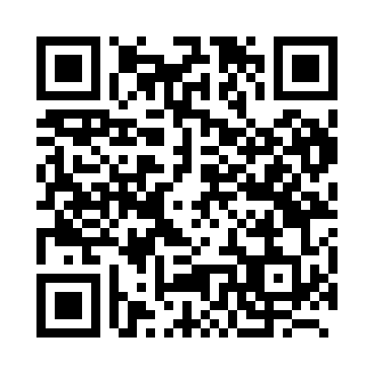
Prayer times for Delbart, Belgium
Mon 1 Apr 2024 - Tue 30 Apr 2024
High Latitude Method: Angle Based Rule
Prayer Calculation Method: Muslim World League
Asar Calculation Method: Shafi

Date | Day | Fajr | Sunrise | Dhuhr | Asr | Maghrib | Isha
1 | Mon | 5:25 | 7:21 | 1:49 | 5:23 | 8:19 | 10:08
2 | Tue | 5:22 | 7:19 | 1:49 | 5:24 | 8:21 | 10:10
3 | Wed | 5:19 | 7:17 | 1:49 | 5:25 | 8:22 | 10:12
4 | Thu | 5:17 | 7:14 | 1:49 | 5:26 | 8:24 | 10:14
5 | Fri | 5:14 | 7:12 | 1:48 | 5:26 | 8:25 | 10:16
6 | Sat | 5:11 | 7:10 | 1:48 | 5:27 | 8:27 | 10:19
7 | Sun | 5:08 | 7:08 | 1:48 | 5:28 | 8:29 | 10:21
8 | Mon | 5:05 | 7:06 | 1:47 | 5:29 | 8:30 | 10:23
9 | Tue | 5:03 | 7:03 | 1:47 | 5:30 | 8:32 | 10:25
10 | Wed | 5:00 | 7:01 | 1:47 | 5:30 | 8:33 | 10:28
11 | Thu | 4:57 | 6:59 | 1:47 | 5:31 | 8:35 | 10:30
12 | Fri | 4:54 | 6:57 | 1:46 | 5:32 | 8:37 | 10:32
13 | Sat | 4:51 | 6:55 | 1:46 | 5:33 | 8:38 | 10:34
14 | Sun | 4:48 | 6:53 | 1:46 | 5:33 | 8:40 | 10:37
15 | Mon | 4:45 | 6:51 | 1:46 | 5:34 | 8:41 | 10:39
16 | Tue | 4:42 | 6:49 | 1:45 | 5:35 | 8:43 | 10:42
17 | Wed | 4:39 | 6:47 | 1:45 | 5:36 | 8:45 | 10:44
18 | Thu | 4:36 | 6:45 | 1:45 | 5:36 | 8:46 | 10:46
19 | Fri | 4:33 | 6:42 | 1:45 | 5:37 | 8:48 | 10:49
20 | Sat | 4:30 | 6:40 | 1:45 | 5:38 | 8:50 | 10:51
21 | Sun | 4:27 | 6:38 | 1:44 | 5:38 | 8:51 | 10:54
22 | Mon | 4:24 | 6:36 | 1:44 | 5:39 | 8:53 | 10:57
23 | Tue | 4:21 | 6:34 | 1:44 | 5:40 | 8:54 | 10:59
24 | Wed | 4:18 | 6:33 | 1:44 | 5:40 | 8:56 | 11:02
25 | Thu | 4:15 | 6:31 | 1:44 | 5:41 | 8:58 | 11:04
26 | Fri | 4:11 | 6:29 | 1:43 | 5:42 | 8:59 | 11:07
27 | Sat | 4:08 | 6:27 | 1:43 | 5:42 | 9:01 | 11:10
28 | Sun | 4:05 | 6:25 | 1:43 | 5:43 | 9:02 | 11:13
29 | Mon | 4:02 | 6:23 | 1:43 | 5:44 | 9:04 | 11:15
30 | Tue | 3:59 | 6:21 | 1:43 | 5:44 | 9:06 | 11:18
Prayer times provided by https://www.salahtimes.com

