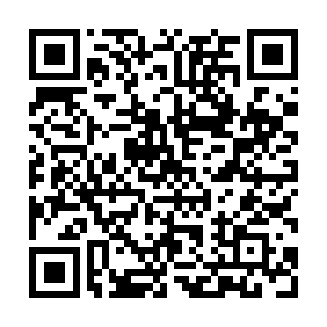
Prayer times for San Ambrosio Island, Chile
Mon 1 Apr 2024 - Tue 30 Apr 2024
High Latitude Method: None
Prayer Calculation Method: Muslim World League
Asar Calculation Method: Shafi

Date | Day | Fajr | Sunrise | Dhuhr | Asr | Maghrib | Isha
1 | Mon | 7:12 | 8:29 | 2:23 | 5:46 | 8:17 | 9:29
2 | Tue | 7:13 | 8:30 | 2:23 | 5:45 | 8:16 | 9:28
3 | Wed | 7:13 | 8:30 | 2:23 | 5:44 | 8:15 | 9:27
4 | Thu | 7:14 | 8:31 | 2:22 | 5:44 | 8:14 | 9:26
5 | Fri | 7:14 | 8:31 | 2:22 | 5:43 | 8:13 | 9:25
6 | Sat | 7:15 | 8:32 | 2:22 | 5:42 | 8:12 | 9:24
7 | Sun | 6:15 | 7:32 | 1:22 | 4:42 | 7:11 | 8:23
8 | Mon | 6:16 | 7:32 | 1:21 | 4:41 | 7:10 | 8:22
9 | Tue | 6:16 | 7:33 | 1:21 | 4:40 | 7:09 | 8:21
10 | Wed | 6:16 | 7:33 | 1:21 | 4:40 | 7:08 | 8:20
11 | Thu | 6:17 | 7:34 | 1:20 | 4:39 | 7:07 | 8:19
12 | Fri | 6:17 | 7:34 | 1:20 | 4:38 | 7:06 | 8:18
13 | Sat | 6:18 | 7:35 | 1:20 | 4:38 | 7:05 | 8:17
14 | Sun | 6:18 | 7:35 | 1:20 | 4:37 | 7:04 | 8:16
15 | Mon | 6:19 | 7:36 | 1:19 | 4:36 | 7:03 | 8:16
16 | Tue | 6:19 | 7:36 | 1:19 | 4:36 | 7:02 | 8:15
17 | Wed | 6:19 | 7:37 | 1:19 | 4:35 | 7:01 | 8:14
18 | Thu | 6:20 | 7:37 | 1:19 | 4:34 | 7:00 | 8:13
19 | Fri | 6:20 | 7:38 | 1:19 | 4:34 | 6:59 | 8:12
20 | Sat | 6:21 | 7:38 | 1:18 | 4:33 | 6:58 | 8:11
21 | Sun | 6:21 | 7:39 | 1:18 | 4:32 | 6:57 | 8:10
22 | Mon | 6:22 | 7:39 | 1:18 | 4:32 | 6:56 | 8:10
23 | Tue | 6:22 | 7:40 | 1:18 | 4:31 | 6:55 | 8:09
24 | Wed | 6:22 | 7:40 | 1:18 | 4:30 | 6:55 | 8:08
25 | Thu | 6:23 | 7:41 | 1:17 | 4:30 | 6:54 | 8:07
26 | Fri | 6:23 | 7:41 | 1:17 | 4:29 | 6:53 | 8:07
27 | Sat | 6:24 | 7:42 | 1:17 | 4:28 | 6:52 | 8:06
28 | Sun | 6:24 | 7:42 | 1:17 | 4:28 | 6:51 | 8:05
29 | Mon | 6:24 | 7:43 | 1:17 | 4:27 | 6:51 | 8:04
30 | Tue | 6:25 | 7:43 | 1:17 | 4:27 | 6:50 | 8:04
Prayer times provided by https://www.salahtimes.com

