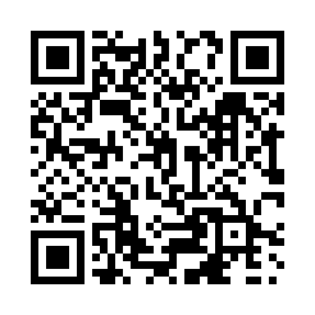
Prayer times for The Green, Newfoundland and Labrador, Canada
Mon 1 Apr 2024 - Tue 30 Apr 2024
High Latitude Method: Angle Based Rule
Prayer Calculation Method: Islamic Society of North America
Asar Calculation Method: Hanafi

Date | Day | Fajr | Sunrise | Dhuhr | Asr | Maghrib | Isha
1 | Mon | 5:12 | 6:39 | 1:05 | 5:34 | 7:32 | 9:01
2 | Tue | 5:09 | 6:37 | 1:05 | 5:35 | 7:34 | 9:02
3 | Wed | 5:07 | 6:35 | 1:05 | 5:36 | 7:35 | 9:04
4 | Thu | 5:05 | 6:33 | 1:05 | 5:37 | 7:37 | 9:06
5 | Fri | 5:02 | 6:31 | 1:04 | 5:38 | 7:38 | 9:07
6 | Sat | 5:00 | 6:29 | 1:04 | 5:39 | 7:40 | 9:09
7 | Sun | 4:58 | 6:27 | 1:04 | 5:40 | 7:41 | 9:11
8 | Mon | 4:55 | 6:25 | 1:03 | 5:41 | 7:42 | 9:13
9 | Tue | 4:53 | 6:24 | 1:03 | 5:42 | 7:44 | 9:15
10 | Wed | 4:51 | 6:22 | 1:03 | 5:43 | 7:45 | 9:16
11 | Thu | 4:48 | 6:20 | 1:03 | 5:44 | 7:47 | 9:18
12 | Fri | 4:46 | 6:18 | 1:02 | 5:45 | 7:48 | 9:20
13 | Sat | 4:44 | 6:16 | 1:02 | 5:46 | 7:49 | 9:22
14 | Sun | 4:41 | 6:14 | 1:02 | 5:47 | 7:51 | 9:24
15 | Mon | 4:39 | 6:12 | 1:02 | 5:48 | 7:52 | 9:26
16 | Tue | 4:37 | 6:10 | 1:01 | 5:49 | 7:54 | 9:27
17 | Wed | 4:34 | 6:08 | 1:01 | 5:50 | 7:55 | 9:29
18 | Thu | 4:32 | 6:06 | 1:01 | 5:51 | 7:56 | 9:31
19 | Fri | 4:30 | 6:05 | 1:01 | 5:52 | 7:58 | 9:33
20 | Sat | 4:27 | 6:03 | 1:01 | 5:52 | 7:59 | 9:35
21 | Sun | 4:25 | 6:01 | 1:00 | 5:53 | 8:01 | 9:37
22 | Mon | 4:23 | 5:59 | 1:00 | 5:54 | 8:02 | 9:39
23 | Tue | 4:20 | 5:57 | 1:00 | 5:55 | 8:04 | 9:41
24 | Wed | 4:18 | 5:56 | 1:00 | 5:56 | 8:05 | 9:43
25 | Thu | 4:16 | 5:54 | 1:00 | 5:57 | 8:06 | 9:45
26 | Fri | 4:13 | 5:52 | 1:00 | 5:58 | 8:08 | 9:47
27 | Sat | 4:11 | 5:50 | 12:59 | 5:59 | 8:09 | 9:49
28 | Sun | 4:09 | 5:49 | 12:59 | 5:59 | 8:11 | 9:51
29 | Mon | 4:06 | 5:47 | 12:59 | 6:00 | 8:12 | 9:53
30 | Tue | 4:04 | 5:45 | 12:59 | 6:01 | 8:13 | 9:55
Prayer times provided by https://www.salahtimes.com

