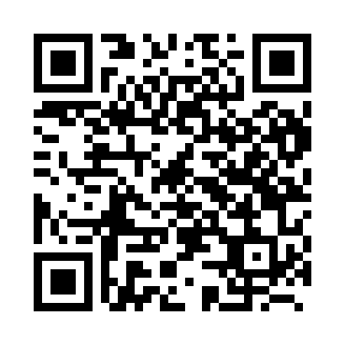
Prayer times for Broeke, Belgium
Mon 1 Apr 2024 - Tue 30 Apr 2024
High Latitude Method: Angle Based Rule
Prayer Calculation Method: Muslim World League
Asar Calculation Method: Shafi

Date | Day | Fajr | Sunrise | Dhuhr | Asr | Maghrib | Isha
1 | Mon | 5:24 | 7:20 | 1:49 | 5:23 | 8:19 | 10:08
2 | Tue | 5:21 | 7:18 | 1:49 | 5:23 | 8:20 | 10:10
3 | Wed | 5:18 | 7:16 | 1:48 | 5:24 | 8:22 | 10:12
4 | Thu | 5:15 | 7:14 | 1:48 | 5:25 | 8:24 | 10:15
5 | Fri | 5:13 | 7:12 | 1:48 | 5:26 | 8:25 | 10:17
6 | Sat | 5:10 | 7:09 | 1:48 | 5:27 | 8:27 | 10:19
7 | Sun | 5:07 | 7:07 | 1:47 | 5:28 | 8:28 | 10:21
8 | Mon | 5:04 | 7:05 | 1:47 | 5:28 | 8:30 | 10:23
9 | Tue | 5:01 | 7:03 | 1:47 | 5:29 | 8:32 | 10:26
10 | Wed | 4:58 | 7:01 | 1:47 | 5:30 | 8:33 | 10:28
11 | Thu | 4:56 | 6:59 | 1:46 | 5:31 | 8:35 | 10:30
12 | Fri | 4:53 | 6:56 | 1:46 | 5:31 | 8:37 | 10:33
13 | Sat | 4:50 | 6:54 | 1:46 | 5:32 | 8:38 | 10:35
14 | Sun | 4:47 | 6:52 | 1:46 | 5:33 | 8:40 | 10:37
15 | Mon | 4:44 | 6:50 | 1:45 | 5:34 | 8:41 | 10:40
16 | Tue | 4:41 | 6:48 | 1:45 | 5:34 | 8:43 | 10:42
17 | Wed | 4:38 | 6:46 | 1:45 | 5:35 | 8:45 | 10:45
18 | Thu | 4:35 | 6:44 | 1:45 | 5:36 | 8:46 | 10:47
19 | Fri | 4:32 | 6:42 | 1:44 | 5:37 | 8:48 | 10:50
20 | Sat | 4:29 | 6:40 | 1:44 | 5:37 | 8:50 | 10:52
21 | Sun | 4:25 | 6:38 | 1:44 | 5:38 | 8:51 | 10:55
22 | Mon | 4:22 | 6:36 | 1:44 | 5:39 | 8:53 | 10:57
23 | Tue | 4:19 | 6:34 | 1:44 | 5:39 | 8:54 | 11:00
24 | Wed | 4:16 | 6:32 | 1:43 | 5:40 | 8:56 | 11:03
25 | Thu | 4:13 | 6:30 | 1:43 | 5:41 | 8:58 | 11:05
26 | Fri | 4:10 | 6:28 | 1:43 | 5:41 | 8:59 | 11:08
27 | Sat | 4:06 | 6:26 | 1:43 | 5:42 | 9:01 | 11:11
28 | Sun | 4:03 | 6:24 | 1:43 | 5:43 | 9:02 | 11:13
29 | Mon | 4:00 | 6:22 | 1:43 | 5:43 | 9:04 | 11:16
30 | Tue | 3:57 | 6:20 | 1:43 | 5:44 | 9:06 | 11:19
Prayer times provided by https://www.salahtimes.com

