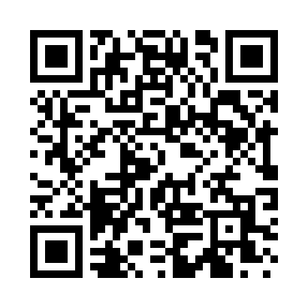
Prayer times for Coxsackie, New York, USA
Mon 1 Apr 2024 - Tue 30 Apr 2024
High Latitude Method: Angle Based Rule
Prayer Calculation Method: Islamic Society of North America
Asar Calculation Method: Shafi

Date | Day | Fajr | Sunrise | Dhuhr | Asr | Maghrib | Isha
1 | Mon | 5:18 | 6:37 | 12:59 | 4:34 | 7:22 | 8:41
2 | Tue | 5:16 | 6:35 | 12:59 | 4:34 | 7:23 | 8:42
3 | Wed | 5:14 | 6:33 | 12:58 | 4:35 | 7:24 | 8:44
4 | Thu | 5:12 | 6:32 | 12:58 | 4:35 | 7:25 | 8:45
5 | Fri | 5:10 | 6:30 | 12:58 | 4:36 | 7:26 | 8:46
6 | Sat | 5:08 | 6:28 | 12:57 | 4:36 | 7:27 | 8:48
7 | Sun | 5:06 | 6:27 | 12:57 | 4:37 | 7:28 | 8:49
8 | Mon | 5:04 | 6:25 | 12:57 | 4:37 | 7:30 | 8:51
9 | Tue | 5:02 | 6:23 | 12:57 | 4:38 | 7:31 | 8:52
10 | Wed | 5:00 | 6:22 | 12:56 | 4:38 | 7:32 | 8:53
11 | Thu | 4:58 | 6:20 | 12:56 | 4:38 | 7:33 | 8:55
12 | Fri | 4:56 | 6:18 | 12:56 | 4:39 | 7:34 | 8:56
13 | Sat | 4:55 | 6:17 | 12:56 | 4:39 | 7:35 | 8:58
14 | Sun | 4:53 | 6:15 | 12:55 | 4:40 | 7:36 | 8:59
15 | Mon | 4:51 | 6:13 | 12:55 | 4:40 | 7:37 | 9:00
16 | Tue | 4:49 | 6:12 | 12:55 | 4:40 | 7:39 | 9:02
17 | Wed | 4:47 | 6:10 | 12:55 | 4:41 | 7:40 | 9:03
18 | Thu | 4:45 | 6:09 | 12:54 | 4:41 | 7:41 | 9:05
19 | Fri | 4:43 | 6:07 | 12:54 | 4:42 | 7:42 | 9:06
20 | Sat | 4:41 | 6:06 | 12:54 | 4:42 | 7:43 | 9:08
21 | Sun | 4:39 | 6:04 | 12:54 | 4:42 | 7:44 | 9:09
22 | Mon | 4:38 | 6:03 | 12:54 | 4:43 | 7:45 | 9:11
23 | Tue | 4:36 | 6:01 | 12:53 | 4:43 | 7:46 | 9:12
24 | Wed | 4:34 | 6:00 | 12:53 | 4:43 | 7:48 | 9:14
25 | Thu | 4:32 | 5:58 | 12:53 | 4:44 | 7:49 | 9:15
26 | Fri | 4:30 | 5:57 | 12:53 | 4:44 | 7:50 | 9:17
27 | Sat | 4:28 | 5:55 | 12:53 | 4:44 | 7:51 | 9:18
28 | Sun | 4:27 | 5:54 | 12:53 | 4:45 | 7:52 | 9:20
29 | Mon | 4:25 | 5:52 | 12:52 | 4:45 | 7:53 | 9:21
30 | Tue | 4:23 | 5:51 | 12:52 | 4:45 | 7:54 | 9:23
Prayer times provided by https://www.salahtimes.com

