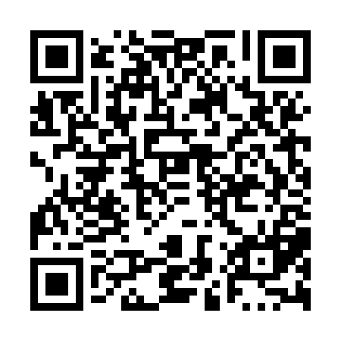
Prayer times for Buffalo Narrows, Saskatchewan, Canada
Mon 1 Jul 2024 - Wed 31 Jul 2024
High Latitude Method: Angle Based Rule
Prayer Calculation Method: Islamic Society of North America
Asar Calculation Method: Hanafi

Date | Day | Fajr | Sunrise | Dhuhr | Asr | Maghrib | Isha
1 | Mon | 2:56 | 4:34 | 1:18 | 7:05 | 10:02 | 11:40
2 | Tue | 2:57 | 4:35 | 1:18 | 7:05 | 10:01 | 11:40
3 | Wed | 2:57 | 4:36 | 1:19 | 7:05 | 10:01 | 11:39
4 | Thu | 2:58 | 4:37 | 1:19 | 7:04 | 10:00 | 11:39
5 | Fri | 2:58 | 4:38 | 1:19 | 7:04 | 9:59 | 11:39
6 | Sat | 2:59 | 4:39 | 1:19 | 7:04 | 9:58 | 11:39
7 | Sun | 3:00 | 4:40 | 1:19 | 7:03 | 9:58 | 11:38
8 | Mon | 3:00 | 4:41 | 1:19 | 7:03 | 9:57 | 11:38
9 | Tue | 3:01 | 4:43 | 1:19 | 7:03 | 9:56 | 11:37
10 | Wed | 3:02 | 4:44 | 1:20 | 7:02 | 9:55 | 11:37
11 | Thu | 3:02 | 4:45 | 1:20 | 7:02 | 9:54 | 11:36
12 | Fri | 3:03 | 4:47 | 1:20 | 7:01 | 9:52 | 11:36
13 | Sat | 3:04 | 4:48 | 1:20 | 7:01 | 9:51 | 11:35
14 | Sun | 3:05 | 4:50 | 1:20 | 7:00 | 9:50 | 11:35
15 | Mon | 3:05 | 4:51 | 1:20 | 6:59 | 9:49 | 11:34
16 | Tue | 3:06 | 4:53 | 1:20 | 6:59 | 9:47 | 11:34
17 | Wed | 3:07 | 4:54 | 1:20 | 6:58 | 9:46 | 11:33
18 | Thu | 3:08 | 4:56 | 1:20 | 6:57 | 9:44 | 11:32
19 | Fri | 3:09 | 4:57 | 1:20 | 6:56 | 9:43 | 11:31
20 | Sat | 3:10 | 4:59 | 1:21 | 6:56 | 9:41 | 11:31
21 | Sun | 3:10 | 5:01 | 1:21 | 6:55 | 9:40 | 11:30
22 | Mon | 3:11 | 5:02 | 1:21 | 6:54 | 9:38 | 11:29
23 | Tue | 3:12 | 5:04 | 1:21 | 6:53 | 9:36 | 11:28
24 | Wed | 3:13 | 5:06 | 1:21 | 6:52 | 9:35 | 11:27
25 | Thu | 3:14 | 5:07 | 1:21 | 6:51 | 9:33 | 11:27
26 | Fri | 3:15 | 5:09 | 1:21 | 6:50 | 9:31 | 11:26
27 | Sat | 3:16 | 5:11 | 1:21 | 6:49 | 9:29 | 11:25
28 | Sun | 3:16 | 5:13 | 1:21 | 6:48 | 9:27 | 11:24
29 | Mon | 3:17 | 5:15 | 1:21 | 6:47 | 9:26 | 11:23
30 | Tue | 3:18 | 5:16 | 1:21 | 6:46 | 9:24 | 11:22
31 | Wed | 3:19 | 5:18 | 1:20 | 6:45 | 9:22 | 11:21
Prayer times provided by https://www.salahtimes.com

