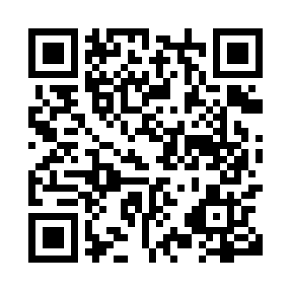
Prayer times for Silver City, Yukon, Canada
Mon 1 Jul 2024 - Wed 31 Jul 2024
High Latitude Method: Angle Based Rule
Prayer Calculation Method: Islamic Society of North America
Asar Calculation Method: Hanafi

Date | Day | Fajr | Sunrise | Dhuhr | Asr | Maghrib | Isha
1 | Mon | 3:31 | 4:45 | 2:18 | 8:20 | 11:50 | 1:04
2 | Tue | 3:32 | 4:46 | 2:18 | 8:19 | 11:49 | 1:03
3 | Wed | 3:32 | 4:47 | 2:18 | 8:19 | 11:48 | 1:03
4 | Thu | 3:33 | 4:49 | 2:18 | 8:19 | 11:47 | 1:02
5 | Fri | 3:34 | 4:50 | 2:18 | 8:18 | 11:46 | 1:02
6 | Sat | 3:35 | 4:52 | 2:19 | 8:18 | 11:44 | 1:01
7 | Sun | 3:36 | 4:54 | 2:19 | 8:17 | 11:43 | 1:01
8 | Mon | 3:37 | 4:55 | 2:19 | 8:17 | 11:42 | 1:00
9 | Tue | 3:38 | 4:57 | 2:19 | 8:16 | 11:40 | 12:59
10 | Wed | 3:39 | 4:59 | 2:19 | 8:16 | 11:38 | 12:59
11 | Thu | 3:40 | 5:01 | 2:19 | 8:15 | 11:37 | 12:58
12 | Fri | 3:41 | 5:03 | 2:19 | 8:14 | 11:35 | 12:57
13 | Sat | 3:42 | 5:05 | 2:19 | 8:14 | 11:33 | 12:56
14 | Sun | 3:43 | 5:07 | 2:20 | 8:13 | 11:31 | 12:55
15 | Mon | 3:44 | 5:09 | 2:20 | 8:12 | 11:29 | 12:54
16 | Tue | 3:45 | 5:11 | 2:20 | 8:11 | 11:27 | 12:53
17 | Wed | 3:46 | 5:13 | 2:20 | 8:10 | 11:25 | 12:52
18 | Thu | 3:47 | 5:15 | 2:20 | 8:09 | 11:23 | 12:51
19 | Fri | 3:49 | 5:18 | 2:20 | 8:08 | 11:21 | 12:50
20 | Sat | 3:50 | 5:20 | 2:20 | 8:07 | 11:19 | 12:49
21 | Sun | 3:51 | 5:22 | 2:20 | 8:06 | 11:17 | 12:48
22 | Mon | 3:52 | 5:25 | 2:20 | 8:05 | 11:14 | 12:47
23 | Tue | 3:53 | 5:27 | 2:20 | 8:04 | 11:12 | 12:46
24 | Wed | 3:54 | 5:29 | 2:20 | 8:03 | 11:10 | 12:45
25 | Thu | 3:56 | 5:32 | 2:20 | 8:02 | 11:07 | 12:43
26 | Fri | 3:57 | 5:34 | 2:20 | 8:00 | 11:05 | 12:42
27 | Sat | 3:58 | 5:37 | 2:20 | 7:59 | 11:02 | 12:41
28 | Sun | 3:59 | 5:39 | 2:20 | 7:58 | 11:00 | 12:40
29 | Mon | 4:01 | 5:42 | 2:20 | 7:56 | 10:57 | 12:38
30 | Tue | 4:02 | 5:44 | 2:20 | 7:55 | 10:54 | 12:37
31 | Wed | 4:03 | 5:47 | 2:20 | 7:54 | 10:52 | 12:36
Prayer times provided by https://www.salahtimes.com

