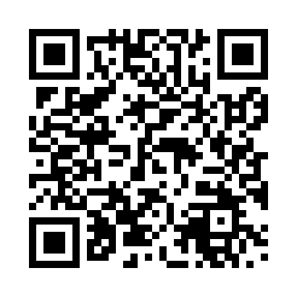
Prayer times for Tronitz, Germany
Wed 1 May 2024 - Fri 31 May 2024
High Latitude Method: Angle Based Rule
Prayer Calculation Method: Muslim World League
Asar Calculation Method: Shafi

Date | Day | Fajr | Sunrise | Dhuhr | Asr | Maghrib | Isha
1 | Wed | 3:11 | 5:39 | 1:04 | 5:06 | 8:29 | 10:46
2 | Thu | 3:08 | 5:37 | 1:03 | 5:07 | 8:31 | 10:49
3 | Fri | 3:04 | 5:35 | 1:03 | 5:07 | 8:32 | 10:52
4 | Sat | 3:01 | 5:33 | 1:03 | 5:08 | 8:34 | 10:55
5 | Sun | 2:57 | 5:31 | 1:03 | 5:09 | 8:36 | 10:58
6 | Mon | 2:54 | 5:30 | 1:03 | 5:09 | 8:37 | 11:01
7 | Tue | 2:50 | 5:28 | 1:03 | 5:10 | 8:39 | 11:05
8 | Wed | 2:49 | 5:26 | 1:03 | 5:11 | 8:40 | 11:08
9 | Thu | 2:48 | 5:25 | 1:03 | 5:11 | 8:42 | 11:10
10 | Fri | 2:47 | 5:23 | 1:03 | 5:12 | 8:43 | 11:11
11 | Sat | 2:47 | 5:21 | 1:03 | 5:12 | 8:45 | 11:11
12 | Sun | 2:46 | 5:20 | 1:03 | 5:13 | 8:47 | 11:12
13 | Mon | 2:45 | 5:18 | 1:03 | 5:14 | 8:48 | 11:13
14 | Tue | 2:45 | 5:17 | 1:03 | 5:14 | 8:50 | 11:13
15 | Wed | 2:44 | 5:15 | 1:03 | 5:15 | 8:51 | 11:14
16 | Thu | 2:44 | 5:14 | 1:03 | 5:15 | 8:52 | 11:15
17 | Fri | 2:43 | 5:13 | 1:03 | 5:16 | 8:54 | 11:15
18 | Sat | 2:42 | 5:11 | 1:03 | 5:16 | 8:55 | 11:16
19 | Sun | 2:42 | 5:10 | 1:03 | 5:17 | 8:57 | 11:16
20 | Mon | 2:41 | 5:09 | 1:03 | 5:18 | 8:58 | 11:17
21 | Tue | 2:41 | 5:07 | 1:03 | 5:18 | 8:59 | 11:18
22 | Wed | 2:41 | 5:06 | 1:03 | 5:19 | 9:01 | 11:18
23 | Thu | 2:40 | 5:05 | 1:03 | 5:19 | 9:02 | 11:19
24 | Fri | 2:40 | 5:04 | 1:03 | 5:20 | 9:03 | 11:20
25 | Sat | 2:39 | 5:03 | 1:03 | 5:20 | 9:05 | 11:20
26 | Sun | 2:39 | 5:02 | 1:04 | 5:21 | 9:06 | 11:21
27 | Mon | 2:39 | 5:01 | 1:04 | 5:21 | 9:07 | 11:21
28 | Tue | 2:38 | 5:00 | 1:04 | 5:22 | 9:08 | 11:22
29 | Wed | 2:38 | 4:59 | 1:04 | 5:22 | 9:10 | 11:23
30 | Thu | 2:38 | 4:58 | 1:04 | 5:23 | 9:11 | 11:23
31 | Fri | 2:38 | 4:57 | 1:04 | 5:23 | 9:12 | 11:24
Prayer times provided by https://www.salahtimes.com

