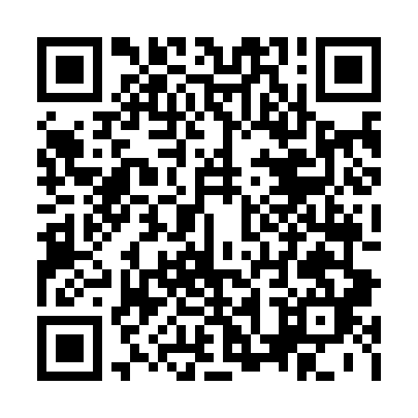
Prayer times for Panmunjom, South Korea
Mon 1 Apr 2024 - Tue 30 Apr 2024
High Latitude Method: None
Prayer Calculation Method: Muslim World League
Asar Calculation Method: Shafi

Date | Day | Fajr | Sunrise | Dhuhr | Asr | Maghrib | Isha
1 | Mon | 4:49 | 6:19 | 12:37 | 4:11 | 6:56 | 8:21
2 | Tue | 4:47 | 6:17 | 12:37 | 4:12 | 6:57 | 8:22
3 | Wed | 4:45 | 6:16 | 12:37 | 4:12 | 6:58 | 8:23
4 | Thu | 4:44 | 6:14 | 12:36 | 4:12 | 6:59 | 8:24
5 | Fri | 4:42 | 6:13 | 12:36 | 4:13 | 7:00 | 8:25
6 | Sat | 4:40 | 6:11 | 12:36 | 4:13 | 7:01 | 8:26
7 | Sun | 4:38 | 6:10 | 12:35 | 4:13 | 7:02 | 8:28
8 | Mon | 4:37 | 6:08 | 12:35 | 4:13 | 7:03 | 8:29
9 | Tue | 4:35 | 6:07 | 12:35 | 4:14 | 7:04 | 8:30
10 | Wed | 4:33 | 6:05 | 12:35 | 4:14 | 7:05 | 8:31
11 | Thu | 4:32 | 6:04 | 12:34 | 4:14 | 7:06 | 8:32
12 | Fri | 4:30 | 6:02 | 12:34 | 4:14 | 7:06 | 8:33
13 | Sat | 4:28 | 6:01 | 12:34 | 4:15 | 7:07 | 8:35
14 | Sun | 4:26 | 5:59 | 12:34 | 4:15 | 7:08 | 8:36
15 | Mon | 4:25 | 5:58 | 12:33 | 4:15 | 7:09 | 8:37
16 | Tue | 4:23 | 5:57 | 12:33 | 4:15 | 7:10 | 8:38
17 | Wed | 4:21 | 5:55 | 12:33 | 4:16 | 7:11 | 8:39
18 | Thu | 4:20 | 5:54 | 12:33 | 4:16 | 7:12 | 8:41
19 | Fri | 4:18 | 5:52 | 12:32 | 4:16 | 7:13 | 8:42
20 | Sat | 4:16 | 5:51 | 12:32 | 4:16 | 7:14 | 8:43
21 | Sun | 4:14 | 5:50 | 12:32 | 4:16 | 7:15 | 8:44
22 | Mon | 4:13 | 5:48 | 12:32 | 4:17 | 7:16 | 8:46
23 | Tue | 4:11 | 5:47 | 12:32 | 4:17 | 7:17 | 8:47
24 | Wed | 4:09 | 5:46 | 12:31 | 4:17 | 7:18 | 8:48
25 | Thu | 4:08 | 5:45 | 12:31 | 4:17 | 7:19 | 8:49
26 | Fri | 4:06 | 5:43 | 12:31 | 4:17 | 7:19 | 8:51
27 | Sat | 4:05 | 5:42 | 12:31 | 4:18 | 7:20 | 8:52
28 | Sun | 4:03 | 5:41 | 12:31 | 4:18 | 7:21 | 8:53
29 | Mon | 4:01 | 5:40 | 12:31 | 4:18 | 7:22 | 8:55
30 | Tue | 4:00 | 5:38 | 12:31 | 4:18 | 7:23 | 8:56
Prayer times provided by https://www.salahtimes.com

