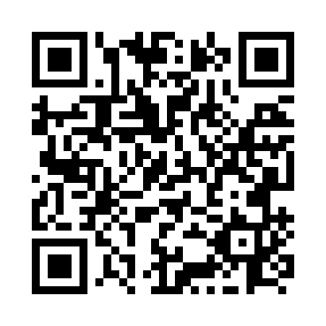
Prayer times for Val-Morin, Quebec, Canada
Wed 1 May 2024 - Fri 31 May 2024
High Latitude Method: Angle Based Rule
Prayer Calculation Method: Islamic Society of North America
Asar Calculation Method: Hanafi

Date | Day | Fajr | Sunrise | Dhuhr | Asr | Maghrib | Isha
1 | Wed | 4:06 | 5:43 | 12:54 | 5:55 | 8:05 | 9:43
2 | Thu | 4:04 | 5:41 | 12:54 | 5:56 | 8:07 | 9:45
3 | Fri | 4:02 | 5:40 | 12:54 | 5:57 | 8:08 | 9:47
4 | Sat | 4:00 | 5:38 | 12:53 | 5:58 | 8:09 | 9:48
5 | Sun | 3:58 | 5:37 | 12:53 | 5:58 | 8:11 | 9:50
6 | Mon | 3:56 | 5:35 | 12:53 | 5:59 | 8:12 | 9:52
7 | Tue | 3:54 | 5:34 | 12:53 | 6:00 | 8:13 | 9:54
8 | Wed | 3:52 | 5:33 | 12:53 | 6:01 | 8:14 | 9:56
9 | Thu | 3:50 | 5:31 | 12:53 | 6:01 | 8:16 | 9:58
10 | Fri | 3:48 | 5:30 | 12:53 | 6:02 | 8:17 | 10:00
11 | Sat | 3:46 | 5:29 | 12:53 | 6:03 | 8:18 | 10:02
12 | Sun | 3:44 | 5:27 | 12:53 | 6:04 | 8:19 | 10:03
13 | Mon | 3:42 | 5:26 | 12:53 | 6:04 | 8:21 | 10:05
14 | Tue | 3:40 | 5:25 | 12:53 | 6:05 | 8:22 | 10:07
15 | Wed | 3:38 | 5:24 | 12:53 | 6:06 | 8:23 | 10:09
16 | Thu | 3:37 | 5:23 | 12:53 | 6:06 | 8:24 | 10:11
17 | Fri | 3:35 | 5:22 | 12:53 | 6:07 | 8:25 | 10:13
18 | Sat | 3:33 | 5:21 | 12:53 | 6:08 | 8:26 | 10:14
19 | Sun | 3:31 | 5:20 | 12:53 | 6:08 | 8:28 | 10:16
20 | Mon | 3:30 | 5:19 | 12:53 | 6:09 | 8:29 | 10:18
21 | Tue | 3:28 | 5:18 | 12:53 | 6:10 | 8:30 | 10:20
22 | Wed | 3:26 | 5:17 | 12:53 | 6:10 | 8:31 | 10:21
23 | Thu | 3:25 | 5:16 | 12:54 | 6:11 | 8:32 | 10:23
24 | Fri | 3:23 | 5:15 | 12:54 | 6:12 | 8:33 | 10:25
25 | Sat | 3:22 | 5:14 | 12:54 | 6:12 | 8:34 | 10:26
26 | Sun | 3:20 | 5:13 | 12:54 | 6:13 | 8:35 | 10:28
27 | Mon | 3:19 | 5:12 | 12:54 | 6:13 | 8:36 | 10:30
28 | Tue | 3:18 | 5:12 | 12:54 | 6:14 | 8:37 | 10:31
29 | Wed | 3:16 | 5:11 | 12:54 | 6:15 | 8:38 | 10:33
30 | Thu | 3:15 | 5:10 | 12:54 | 6:15 | 8:39 | 10:34
31 | Fri | 3:14 | 5:10 | 12:55 | 6:16 | 8:40 | 10:36
Prayer times provided by https://www.salahtimes.com

