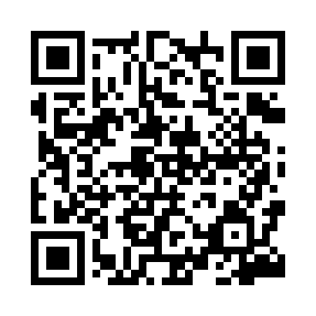
Prayer times for Tolkmicko, Poland
Wed 1 May 2024 - Fri 31 May 2024
High Latitude Method: Angle Based Rule
Prayer Calculation Method: Muslim World League
Asar Calculation Method: Hanafi

Date | Day | Fajr | Sunrise | Dhuhr | Asr | Maghrib | Isha
1 | Wed | 2:25 | 5:03 | 12:39 | 5:49 | 8:15 | 10:45
2 | Thu | 2:24 | 5:01 | 12:39 | 5:50 | 8:17 | 10:46
3 | Fri | 2:23 | 4:59 | 12:39 | 5:52 | 8:19 | 10:47
4 | Sat | 2:22 | 4:57 | 12:39 | 5:53 | 8:21 | 10:47
5 | Sun | 2:22 | 4:55 | 12:39 | 5:54 | 8:23 | 10:48
6 | Mon | 2:21 | 4:53 | 12:38 | 5:55 | 8:25 | 10:49
7 | Tue | 2:20 | 4:51 | 12:38 | 5:56 | 8:26 | 10:49
8 | Wed | 2:19 | 4:49 | 12:38 | 5:57 | 8:28 | 10:50
9 | Thu | 2:18 | 4:48 | 12:38 | 5:58 | 8:30 | 10:51
10 | Fri | 2:18 | 4:46 | 12:38 | 5:59 | 8:32 | 10:52
11 | Sat | 2:17 | 4:44 | 12:38 | 6:00 | 8:34 | 10:52
12 | Sun | 2:16 | 4:42 | 12:38 | 6:01 | 8:35 | 10:53
13 | Mon | 2:15 | 4:40 | 12:38 | 6:02 | 8:37 | 10:54
14 | Tue | 2:15 | 4:39 | 12:38 | 6:03 | 8:39 | 10:55
15 | Wed | 2:14 | 4:37 | 12:38 | 6:04 | 8:41 | 10:55
16 | Thu | 2:13 | 4:35 | 12:38 | 6:05 | 8:42 | 10:56
17 | Fri | 2:13 | 4:34 | 12:38 | 6:06 | 8:44 | 10:57
18 | Sat | 2:12 | 4:32 | 12:38 | 6:07 | 8:46 | 10:58
19 | Sun | 2:11 | 4:30 | 12:38 | 6:08 | 8:47 | 10:58
20 | Mon | 2:11 | 4:29 | 12:38 | 6:09 | 8:49 | 10:59
21 | Tue | 2:10 | 4:27 | 12:39 | 6:10 | 8:50 | 11:00
22 | Wed | 2:10 | 4:26 | 12:39 | 6:11 | 8:52 | 11:01
23 | Thu | 2:09 | 4:25 | 12:39 | 6:12 | 8:53 | 11:01
24 | Fri | 2:09 | 4:23 | 12:39 | 6:13 | 8:55 | 11:02
25 | Sat | 2:08 | 4:22 | 12:39 | 6:13 | 8:56 | 11:03
26 | Sun | 2:08 | 4:21 | 12:39 | 6:14 | 8:58 | 11:03
27 | Mon | 2:07 | 4:20 | 12:39 | 6:15 | 8:59 | 11:04
28 | Tue | 2:07 | 4:18 | 12:39 | 6:16 | 9:01 | 11:05
29 | Wed | 2:07 | 4:17 | 12:39 | 6:17 | 9:02 | 11:05
30 | Thu | 2:06 | 4:16 | 12:40 | 6:17 | 9:03 | 11:06
31 | Fri | 2:06 | 4:15 | 12:40 | 6:18 | 9:05 | 11:07
Prayer times provided by https://www.salahtimes.com

