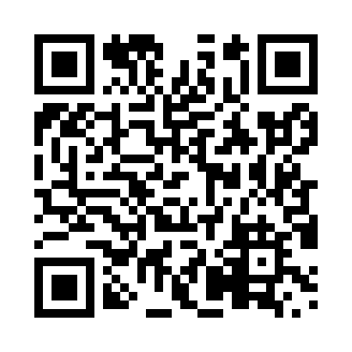
Prayer times for Val-Shefford, Quebec, Canada
Mon 1 Apr 2024 - Tue 30 Apr 2024
High Latitude Method: Angle Based Rule
Prayer Calculation Method: Islamic Society of North America
Asar Calculation Method: Hanafi

Date | Day | Fajr | Sunrise | Dhuhr | Asr | Maghrib | Isha
1 | Mon | 5:06 | 6:30 | 12:54 | 5:24 | 7:19 | 8:43
2 | Tue | 5:04 | 6:28 | 12:54 | 5:24 | 7:21 | 8:45
3 | Wed | 5:02 | 6:26 | 12:54 | 5:25 | 7:22 | 8:47
4 | Thu | 5:00 | 6:24 | 12:53 | 5:26 | 7:23 | 8:48
5 | Fri | 4:57 | 6:22 | 12:53 | 5:27 | 7:24 | 8:50
6 | Sat | 4:55 | 6:20 | 12:53 | 5:28 | 7:26 | 8:51
7 | Sun | 4:53 | 6:19 | 12:52 | 5:29 | 7:27 | 8:53
8 | Mon | 4:51 | 6:17 | 12:52 | 5:30 | 7:28 | 8:54
9 | Tue | 4:49 | 6:15 | 12:52 | 5:31 | 7:30 | 8:56
10 | Wed | 4:47 | 6:13 | 12:52 | 5:31 | 7:31 | 8:58
11 | Thu | 4:45 | 6:11 | 12:51 | 5:32 | 7:32 | 8:59
12 | Fri | 4:42 | 6:10 | 12:51 | 5:33 | 7:33 | 9:01
13 | Sat | 4:40 | 6:08 | 12:51 | 5:34 | 7:35 | 9:02
14 | Sun | 4:38 | 6:06 | 12:51 | 5:35 | 7:36 | 9:04
15 | Mon | 4:36 | 6:04 | 12:50 | 5:36 | 7:37 | 9:06
16 | Tue | 4:34 | 6:02 | 12:50 | 5:37 | 7:39 | 9:07
17 | Wed | 4:32 | 6:01 | 12:50 | 5:37 | 7:40 | 9:09
18 | Thu | 4:30 | 5:59 | 12:50 | 5:38 | 7:41 | 9:11
19 | Fri | 4:27 | 5:57 | 12:49 | 5:39 | 7:42 | 9:13
20 | Sat | 4:25 | 5:56 | 12:49 | 5:40 | 7:44 | 9:14
21 | Sun | 4:23 | 5:54 | 12:49 | 5:41 | 7:45 | 9:16
22 | Mon | 4:21 | 5:52 | 12:49 | 5:41 | 7:46 | 9:18
23 | Tue | 4:19 | 5:51 | 12:49 | 5:42 | 7:48 | 9:19
24 | Wed | 4:17 | 5:49 | 12:49 | 5:43 | 7:49 | 9:21
25 | Thu | 4:15 | 5:47 | 12:48 | 5:44 | 7:50 | 9:23
26 | Fri | 4:13 | 5:46 | 12:48 | 5:45 | 7:51 | 9:25
27 | Sat | 4:11 | 5:44 | 12:48 | 5:45 | 7:53 | 9:26
28 | Sun | 4:09 | 5:43 | 12:48 | 5:46 | 7:54 | 9:28
29 | Mon | 4:07 | 5:41 | 12:48 | 5:47 | 7:55 | 9:30
30 | Tue | 4:05 | 5:39 | 12:48 | 5:48 | 7:57 | 9:32
Prayer times provided by https://www.salahtimes.com

