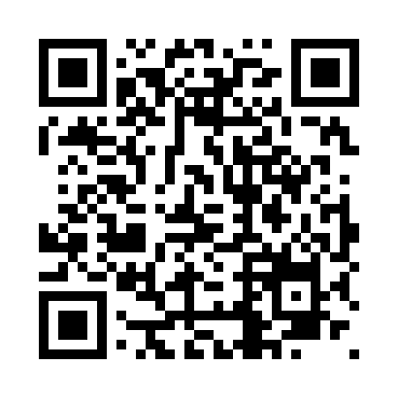
Prayer times for Sexsmith, Alberta, Canada
Mon 1 Jul 2024 - Wed 31 Jul 2024
High Latitude Method: Angle Based Rule
Prayer Calculation Method: Islamic Society of North America
Asar Calculation Method: Hanafi

Date | Day | Fajr | Sunrise | Dhuhr | Asr | Maghrib | Isha
1 | Mon | 3:39 | 5:19 | 1:59 | 7:45 | 10:39 | 12:19
2 | Tue | 3:40 | 5:20 | 1:59 | 7:44 | 10:38 | 12:19
3 | Wed | 3:40 | 5:21 | 2:00 | 7:44 | 10:38 | 12:19
4 | Thu | 3:41 | 5:22 | 2:00 | 7:44 | 10:37 | 12:18
5 | Fri | 3:41 | 5:23 | 2:00 | 7:44 | 10:37 | 12:18
6 | Sat | 3:42 | 5:24 | 2:00 | 7:43 | 10:36 | 12:18
7 | Sun | 3:42 | 5:25 | 2:00 | 7:43 | 10:35 | 12:17
8 | Mon | 3:43 | 5:26 | 2:00 | 7:43 | 10:34 | 12:17
9 | Tue | 3:44 | 5:27 | 2:01 | 7:42 | 10:33 | 12:17
10 | Wed | 3:44 | 5:29 | 2:01 | 7:42 | 10:32 | 12:16
11 | Thu | 3:45 | 5:30 | 2:01 | 7:41 | 10:31 | 12:16
12 | Fri | 3:46 | 5:31 | 2:01 | 7:41 | 10:30 | 12:15
13 | Sat | 3:47 | 5:33 | 2:01 | 7:40 | 10:29 | 12:15
14 | Sun | 3:47 | 5:34 | 2:01 | 7:40 | 10:28 | 12:14
15 | Mon | 3:48 | 5:35 | 2:01 | 7:39 | 10:26 | 12:14
16 | Tue | 3:49 | 5:37 | 2:01 | 7:39 | 10:25 | 12:13
17 | Wed | 3:50 | 5:38 | 2:01 | 7:38 | 10:24 | 12:12
18 | Thu | 3:51 | 5:40 | 2:01 | 7:37 | 10:22 | 12:12
19 | Fri | 3:51 | 5:42 | 2:02 | 7:36 | 10:21 | 12:11
20 | Sat | 3:52 | 5:43 | 2:02 | 7:36 | 10:19 | 12:10
21 | Sun | 3:53 | 5:45 | 2:02 | 7:35 | 10:18 | 12:09
22 | Mon | 3:54 | 5:46 | 2:02 | 7:34 | 10:16 | 12:09
23 | Tue | 3:55 | 5:48 | 2:02 | 7:33 | 10:14 | 12:08
24 | Wed | 3:55 | 5:50 | 2:02 | 7:32 | 10:13 | 12:07
25 | Thu | 3:56 | 5:51 | 2:02 | 7:31 | 10:11 | 12:06
26 | Fri | 3:57 | 5:53 | 2:02 | 7:30 | 10:09 | 12:05
27 | Sat | 3:58 | 5:55 | 2:02 | 7:29 | 10:08 | 12:04
28 | Sun | 3:59 | 5:57 | 2:02 | 7:28 | 10:06 | 12:03
29 | Mon | 4:00 | 5:58 | 2:02 | 7:27 | 10:04 | 12:03
30 | Tue | 4:01 | 6:00 | 2:02 | 7:26 | 10:02 | 12:02
31 | Wed | 4:01 | 6:02 | 2:01 | 7:25 | 10:00 | 12:01
Prayer times provided by https://www.salahtimes.com

