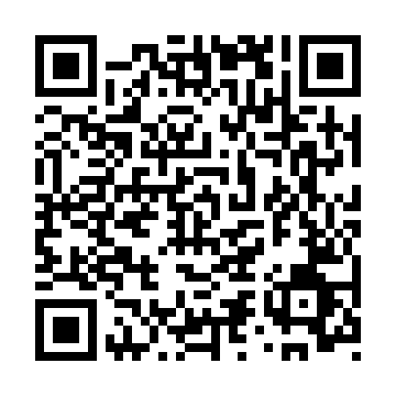
Prayer times for Coquimbito, Argentina
Sat 1 Jun 2024 - Sun 30 Jun 2024
High Latitude Method: None
Prayer Calculation Method: Muslim World League
Asar Calculation Method: Shafi

Date | Day | Fajr | Sunrise | Dhuhr | Asr | Maghrib | Isha
1 | Sat | 7:02 | 8:30 | 1:33 | 4:17 | 6:36 | 7:59
2 | Sun | 7:03 | 8:30 | 1:33 | 4:17 | 6:36 | 7:58
3 | Mon | 7:03 | 8:31 | 1:33 | 4:17 | 6:36 | 7:58
4 | Tue | 7:04 | 8:31 | 1:33 | 4:17 | 6:35 | 7:58
5 | Wed | 7:04 | 8:32 | 1:34 | 4:17 | 6:35 | 7:58
6 | Thu | 7:04 | 8:32 | 1:34 | 4:17 | 6:35 | 7:58
7 | Fri | 7:05 | 8:33 | 1:34 | 4:17 | 6:35 | 7:58
8 | Sat | 7:05 | 8:33 | 1:34 | 4:17 | 6:35 | 7:58
9 | Sun | 7:06 | 8:34 | 1:34 | 4:17 | 6:35 | 7:58
10 | Mon | 7:06 | 8:34 | 1:35 | 4:17 | 6:35 | 7:58
11 | Tue | 7:06 | 8:35 | 1:35 | 4:17 | 6:35 | 7:58
12 | Wed | 7:07 | 8:35 | 1:35 | 4:17 | 6:35 | 7:58
13 | Thu | 7:07 | 8:35 | 1:35 | 4:17 | 6:35 | 7:58
14 | Fri | 7:07 | 8:36 | 1:35 | 4:17 | 6:35 | 7:58
15 | Sat | 7:08 | 8:36 | 1:36 | 4:17 | 6:35 | 7:59
16 | Sun | 7:08 | 8:36 | 1:36 | 4:17 | 6:35 | 7:59
17 | Mon | 7:08 | 8:37 | 1:36 | 4:17 | 6:35 | 7:59
18 | Tue | 7:09 | 8:37 | 1:36 | 4:18 | 6:36 | 7:59
19 | Wed | 7:09 | 8:37 | 1:37 | 4:18 | 6:36 | 7:59
20 | Thu | 7:09 | 8:38 | 1:37 | 4:18 | 6:36 | 7:59
21 | Fri | 7:09 | 8:38 | 1:37 | 4:18 | 6:36 | 8:00
22 | Sat | 7:09 | 8:38 | 1:37 | 4:18 | 6:36 | 8:00
23 | Sun | 7:10 | 8:38 | 1:37 | 4:19 | 6:37 | 8:00
24 | Mon | 7:10 | 8:38 | 1:38 | 4:19 | 6:37 | 8:00
25 | Tue | 7:10 | 8:38 | 1:38 | 4:19 | 6:37 | 8:01
26 | Wed | 7:10 | 8:38 | 1:38 | 4:20 | 6:38 | 8:01
27 | Thu | 7:10 | 8:39 | 1:38 | 4:20 | 6:38 | 8:01
28 | Fri | 7:10 | 8:39 | 1:38 | 4:20 | 6:38 | 8:02
29 | Sat | 7:10 | 8:39 | 1:39 | 4:21 | 6:39 | 8:02
30 | Sun | 7:10 | 8:39 | 1:39 | 4:21 | 6:39 | 8:02
Prayer times provided by https://www.salahtimes.com

