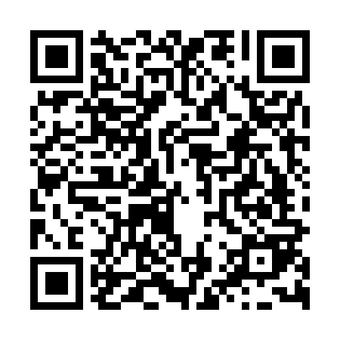
Prayer times for Gunwi County, South Korea
Wed 1 May 2024 - Fri 31 May 2024
High Latitude Method: None
Prayer Calculation Method: Muslim World League
Asar Calculation Method: Shafi

Date | Day | Fajr | Sunrise | Dhuhr | Asr | Maghrib | Isha
1 | Wed | 3:57 | 5:33 | 12:23 | 4:09 | 7:13 | 8:43
2 | Thu | 3:55 | 5:32 | 12:23 | 4:09 | 7:14 | 8:45
3 | Fri | 3:54 | 5:31 | 12:23 | 4:09 | 7:15 | 8:46
4 | Sat | 3:53 | 5:30 | 12:23 | 4:09 | 7:16 | 8:47
5 | Sun | 3:51 | 5:29 | 12:22 | 4:09 | 7:17 | 8:48
6 | Mon | 3:50 | 5:28 | 12:22 | 4:09 | 7:18 | 8:49
7 | Tue | 3:48 | 5:27 | 12:22 | 4:09 | 7:18 | 8:51
8 | Wed | 3:47 | 5:26 | 12:22 | 4:09 | 7:19 | 8:52
9 | Thu | 3:46 | 5:25 | 12:22 | 4:10 | 7:20 | 8:53
10 | Fri | 3:44 | 5:24 | 12:22 | 4:10 | 7:21 | 8:54
11 | Sat | 3:43 | 5:23 | 12:22 | 4:10 | 7:22 | 8:55
12 | Sun | 3:42 | 5:22 | 12:22 | 4:10 | 7:23 | 8:57
13 | Mon | 3:41 | 5:21 | 12:22 | 4:10 | 7:24 | 8:58
14 | Tue | 3:39 | 5:20 | 12:22 | 4:10 | 7:24 | 8:59
15 | Wed | 3:38 | 5:19 | 12:22 | 4:10 | 7:25 | 9:00
16 | Thu | 3:37 | 5:19 | 12:22 | 4:11 | 7:26 | 9:01
17 | Fri | 3:36 | 5:18 | 12:22 | 4:11 | 7:27 | 9:02
18 | Sat | 3:35 | 5:17 | 12:22 | 4:11 | 7:28 | 9:04
19 | Sun | 3:34 | 5:16 | 12:22 | 4:11 | 7:28 | 9:05
20 | Mon | 3:33 | 5:16 | 12:22 | 4:11 | 7:29 | 9:06
21 | Tue | 3:32 | 5:15 | 12:22 | 4:11 | 7:30 | 9:07
22 | Wed | 3:31 | 5:14 | 12:22 | 4:12 | 7:31 | 9:08
23 | Thu | 3:30 | 5:14 | 12:23 | 4:12 | 7:31 | 9:09
24 | Fri | 3:29 | 5:13 | 12:23 | 4:12 | 7:32 | 9:10
25 | Sat | 3:28 | 5:13 | 12:23 | 4:12 | 7:33 | 9:11
26 | Sun | 3:27 | 5:12 | 12:23 | 4:12 | 7:34 | 9:12
27 | Mon | 3:26 | 5:12 | 12:23 | 4:13 | 7:34 | 9:13
28 | Tue | 3:25 | 5:11 | 12:23 | 4:13 | 7:35 | 9:14
29 | Wed | 3:25 | 5:11 | 12:23 | 4:13 | 7:36 | 9:15
30 | Thu | 3:24 | 5:10 | 12:23 | 4:13 | 7:36 | 9:16
31 | Fri | 3:23 | 5:10 | 12:23 | 4:13 | 7:37 | 9:17
Prayer times provided by https://www.salahtimes.com

