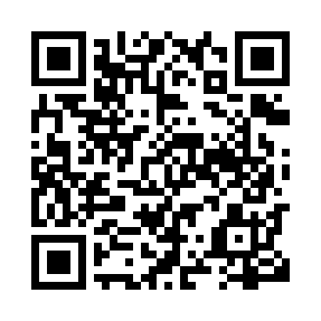
Prayer times for Brochet, Manitoba, Canada
Wed 1 May 2024 - Fri 31 May 2024
High Latitude Method: Angle Based Rule
Prayer Calculation Method: Islamic Society of North America
Asar Calculation Method: Hanafi

Date | Day | Fajr | Sunrise | Dhuhr | Asr | Maghrib | Isha
1 | Wed | 3:49 | 5:53 | 1:44 | 6:59 | 9:36 | 11:40
2 | Thu | 3:47 | 5:51 | 1:44 | 7:00 | 9:38 | 11:41
3 | Fri | 3:46 | 5:48 | 1:44 | 7:02 | 9:40 | 11:42
4 | Sat | 3:45 | 5:46 | 1:43 | 7:03 | 9:42 | 11:43
5 | Sun | 3:44 | 5:43 | 1:43 | 7:04 | 9:44 | 11:44
6 | Mon | 3:42 | 5:41 | 1:43 | 7:05 | 9:47 | 11:45
7 | Tue | 3:41 | 5:39 | 1:43 | 7:07 | 9:49 | 11:46
8 | Wed | 3:40 | 5:36 | 1:43 | 7:08 | 9:51 | 11:47
9 | Thu | 3:39 | 5:34 | 1:43 | 7:09 | 9:53 | 11:48
10 | Fri | 3:38 | 5:32 | 1:43 | 7:10 | 9:55 | 11:49
11 | Sat | 3:37 | 5:30 | 1:43 | 7:12 | 9:57 | 11:50
12 | Sun | 3:36 | 5:28 | 1:43 | 7:13 | 9:59 | 11:52
13 | Mon | 3:35 | 5:26 | 1:43 | 7:14 | 10:02 | 11:53
14 | Tue | 3:34 | 5:24 | 1:43 | 7:15 | 10:04 | 11:54
15 | Wed | 3:33 | 5:21 | 1:43 | 7:16 | 10:06 | 11:55
16 | Thu | 3:32 | 5:19 | 1:43 | 7:17 | 10:08 | 11:56
17 | Fri | 3:31 | 5:18 | 1:43 | 7:19 | 10:10 | 11:57
18 | Sat | 3:30 | 5:16 | 1:43 | 7:20 | 10:12 | 11:58
19 | Sun | 3:29 | 5:14 | 1:43 | 7:21 | 10:14 | 11:59
20 | Mon | 3:28 | 5:12 | 1:43 | 7:22 | 10:16 | 12:00
21 | Tue | 3:27 | 5:10 | 1:43 | 7:23 | 10:18 | 12:01
22 | Wed | 3:26 | 5:08 | 1:43 | 7:24 | 10:19 | 12:02
23 | Thu | 3:25 | 5:07 | 1:44 | 7:25 | 10:21 | 12:03
24 | Fri | 3:25 | 5:05 | 1:44 | 7:26 | 10:23 | 12:04
25 | Sat | 3:24 | 5:03 | 1:44 | 7:27 | 10:25 | 12:04
26 | Sun | 3:23 | 5:02 | 1:44 | 7:28 | 10:27 | 12:05
27 | Mon | 3:22 | 5:00 | 1:44 | 7:29 | 10:28 | 12:06
28 | Tue | 3:22 | 4:59 | 1:44 | 7:30 | 10:30 | 12:07
29 | Wed | 3:21 | 4:58 | 1:44 | 7:30 | 10:32 | 12:08
30 | Thu | 3:20 | 4:56 | 1:44 | 7:31 | 10:33 | 12:09
31 | Fri | 3:20 | 4:55 | 1:45 | 7:32 | 10:35 | 12:10
Prayer times provided by https://www.salahtimes.com

