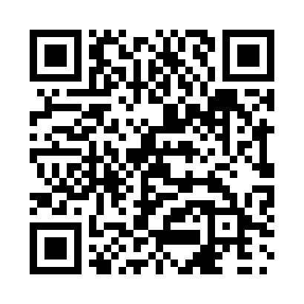
Prayer times for Canoe Cove, Prince Edward Island, Canada
Mon 1 Jul 2024 - Wed 31 Jul 2024
High Latitude Method: Angle Based Rule
Prayer Calculation Method: Islamic Society of North America
Asar Calculation Method: Hanafi

Date | Day | Fajr | Sunrise | Dhuhr | Asr | Maghrib | Isha
1 | Mon | 3:25 | 5:26 | 1:17 | 6:42 | 9:08 | 11:09
2 | Tue | 3:26 | 5:27 | 1:17 | 6:42 | 9:08 | 11:09
3 | Wed | 3:27 | 5:27 | 1:18 | 6:41 | 9:08 | 11:08
4 | Thu | 3:28 | 5:28 | 1:18 | 6:41 | 9:07 | 11:07
5 | Fri | 3:29 | 5:29 | 1:18 | 6:41 | 9:07 | 11:06
6 | Sat | 3:30 | 5:29 | 1:18 | 6:41 | 9:06 | 11:05
7 | Sun | 3:31 | 5:30 | 1:18 | 6:41 | 9:06 | 11:04
8 | Mon | 3:33 | 5:31 | 1:18 | 6:41 | 9:05 | 11:03
9 | Tue | 3:34 | 5:32 | 1:19 | 6:41 | 9:05 | 11:02
10 | Wed | 3:35 | 5:33 | 1:19 | 6:40 | 9:04 | 11:01
11 | Thu | 3:37 | 5:34 | 1:19 | 6:40 | 9:04 | 11:00
12 | Fri | 3:38 | 5:34 | 1:19 | 6:40 | 9:03 | 10:59
13 | Sat | 3:40 | 5:35 | 1:19 | 6:39 | 9:02 | 10:57
14 | Sun | 3:41 | 5:36 | 1:19 | 6:39 | 9:02 | 10:56
15 | Mon | 3:43 | 5:37 | 1:19 | 6:39 | 9:01 | 10:55
16 | Tue | 3:45 | 5:38 | 1:19 | 6:38 | 9:00 | 10:53
17 | Wed | 3:46 | 5:39 | 1:19 | 6:38 | 8:59 | 10:52
18 | Thu | 3:48 | 5:40 | 1:20 | 6:37 | 8:58 | 10:50
19 | Fri | 3:50 | 5:41 | 1:20 | 6:37 | 8:57 | 10:49
20 | Sat | 3:51 | 5:42 | 1:20 | 6:36 | 8:56 | 10:47
21 | Sun | 3:53 | 5:43 | 1:20 | 6:36 | 8:55 | 10:45
22 | Mon | 3:55 | 5:44 | 1:20 | 6:35 | 8:54 | 10:44
23 | Tue | 3:57 | 5:45 | 1:20 | 6:35 | 8:53 | 10:42
24 | Wed | 3:58 | 5:47 | 1:20 | 6:34 | 8:52 | 10:40
25 | Thu | 4:00 | 5:48 | 1:20 | 6:33 | 8:51 | 10:38
26 | Fri | 4:02 | 5:49 | 1:20 | 6:33 | 8:50 | 10:37
27 | Sat | 4:04 | 5:50 | 1:20 | 6:32 | 8:49 | 10:35
28 | Sun | 4:05 | 5:51 | 1:20 | 6:31 | 8:48 | 10:33
29 | Mon | 4:07 | 5:52 | 1:20 | 6:31 | 8:46 | 10:31
30 | Tue | 4:09 | 5:53 | 1:20 | 6:30 | 8:45 | 10:29
31 | Wed | 4:11 | 5:55 | 1:20 | 6:29 | 8:44 | 10:27
Prayer times provided by https://www.salahtimes.com

