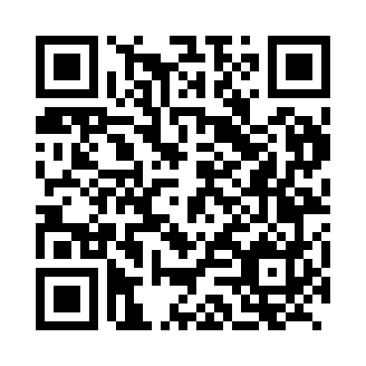
Prayer times for Belsko, Slovenia
Wed 1 May 2024 - Fri 31 May 2024
High Latitude Method: Angle Based Rule
Prayer Calculation Method: Muslim World League
Asar Calculation Method: Hanafi

Date | Day | Fajr | Sunrise | Dhuhr | Asr | Maghrib | Isha
1 | Wed | 3:50 | 5:50 | 1:00 | 6:02 | 8:11 | 10:04
2 | Thu | 3:47 | 5:49 | 1:00 | 6:02 | 8:13 | 10:06
3 | Fri | 3:45 | 5:47 | 1:00 | 6:03 | 8:14 | 10:08
4 | Sat | 3:43 | 5:46 | 1:00 | 6:04 | 8:15 | 10:10
5 | Sun | 3:41 | 5:44 | 1:00 | 6:05 | 8:16 | 10:12
6 | Mon | 3:38 | 5:43 | 1:00 | 6:05 | 8:18 | 10:14
7 | Tue | 3:36 | 5:42 | 1:00 | 6:06 | 8:19 | 10:16
8 | Wed | 3:34 | 5:40 | 1:00 | 6:07 | 8:20 | 10:18
9 | Thu | 3:32 | 5:39 | 1:00 | 6:08 | 8:21 | 10:20
10 | Fri | 3:29 | 5:38 | 1:00 | 6:08 | 8:23 | 10:22
11 | Sat | 3:27 | 5:36 | 1:00 | 6:09 | 8:24 | 10:24
12 | Sun | 3:25 | 5:35 | 1:00 | 6:10 | 8:25 | 10:26
13 | Mon | 3:23 | 5:34 | 1:00 | 6:10 | 8:26 | 10:28
14 | Tue | 3:21 | 5:33 | 1:00 | 6:11 | 8:27 | 10:30
15 | Wed | 3:18 | 5:31 | 1:00 | 6:12 | 8:29 | 10:32
16 | Thu | 3:16 | 5:30 | 1:00 | 6:13 | 8:30 | 10:34
17 | Fri | 3:14 | 5:29 | 1:00 | 6:13 | 8:31 | 10:36
18 | Sat | 3:12 | 5:28 | 1:00 | 6:14 | 8:32 | 10:38
19 | Sun | 3:10 | 5:27 | 1:00 | 6:15 | 8:33 | 10:40
20 | Mon | 3:08 | 5:26 | 1:00 | 6:15 | 8:34 | 10:42
21 | Tue | 3:06 | 5:25 | 1:00 | 6:16 | 8:35 | 10:44
22 | Wed | 3:04 | 5:24 | 1:00 | 6:17 | 8:37 | 10:46
23 | Thu | 3:02 | 5:23 | 1:00 | 6:17 | 8:38 | 10:48
24 | Fri | 3:00 | 5:22 | 1:00 | 6:18 | 8:39 | 10:50
25 | Sat | 2:58 | 5:22 | 1:00 | 6:18 | 8:40 | 10:52
26 | Sun | 2:56 | 5:21 | 1:00 | 6:19 | 8:41 | 10:54
27 | Mon | 2:55 | 5:20 | 1:01 | 6:20 | 8:42 | 10:56
28 | Tue | 2:53 | 5:19 | 1:01 | 6:20 | 8:43 | 10:58
29 | Wed | 2:51 | 5:19 | 1:01 | 6:21 | 8:44 | 10:59
30 | Thu | 2:50 | 5:18 | 1:01 | 6:21 | 8:45 | 11:01
31 | Fri | 2:48 | 5:17 | 1:01 | 6:22 | 8:45 | 11:03
Prayer times provided by https://www.salahtimes.com

