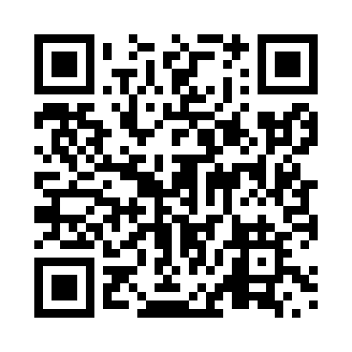
Prayer times for Bruno, Saskatchewan, Canada
Mon 1 Jul 2024 - Wed 31 Jul 2024
High Latitude Method: Angle Based Rule
Prayer Calculation Method: Islamic Society of North America
Asar Calculation Method: Hanafi

Date | Day | Fajr | Sunrise | Dhuhr | Asr | Maghrib | Isha
1 | Mon | 2:56 | 4:46 | 1:06 | 6:44 | 9:26 | 11:16
2 | Tue | 2:56 | 4:46 | 1:06 | 6:44 | 9:26 | 11:16
3 | Wed | 2:57 | 4:47 | 1:07 | 6:44 | 9:26 | 11:16
4 | Thu | 2:57 | 4:48 | 1:07 | 6:43 | 9:25 | 11:16
5 | Fri | 2:58 | 4:49 | 1:07 | 6:43 | 9:25 | 11:16
6 | Sat | 2:58 | 4:50 | 1:07 | 6:43 | 9:24 | 11:15
7 | Sun | 2:59 | 4:51 | 1:07 | 6:43 | 9:23 | 11:15
8 | Mon | 2:59 | 4:52 | 1:07 | 6:42 | 9:22 | 11:15
9 | Tue | 3:00 | 4:53 | 1:07 | 6:42 | 9:22 | 11:14
10 | Wed | 3:01 | 4:54 | 1:08 | 6:42 | 9:21 | 11:14
11 | Thu | 3:01 | 4:55 | 1:08 | 6:41 | 9:20 | 11:14
12 | Fri | 3:02 | 4:56 | 1:08 | 6:41 | 9:19 | 11:13
13 | Sat | 3:02 | 4:57 | 1:08 | 6:40 | 9:18 | 11:13
14 | Sun | 3:03 | 4:58 | 1:08 | 6:40 | 9:17 | 11:12
15 | Mon | 3:04 | 5:00 | 1:08 | 6:39 | 9:16 | 11:12
16 | Tue | 3:04 | 5:01 | 1:08 | 6:39 | 9:15 | 11:11
17 | Wed | 3:05 | 5:02 | 1:08 | 6:38 | 9:14 | 11:11
18 | Thu | 3:06 | 5:04 | 1:08 | 6:38 | 9:13 | 11:10
19 | Fri | 3:07 | 5:05 | 1:08 | 6:37 | 9:11 | 11:10
20 | Sat | 3:07 | 5:06 | 1:09 | 6:36 | 9:10 | 11:09
21 | Sun | 3:08 | 5:08 | 1:09 | 6:36 | 9:09 | 11:09
22 | Mon | 3:09 | 5:09 | 1:09 | 6:35 | 9:07 | 11:08
23 | Tue | 3:09 | 5:10 | 1:09 | 6:34 | 9:06 | 11:07
24 | Wed | 3:10 | 5:12 | 1:09 | 6:33 | 9:05 | 11:06
25 | Thu | 3:11 | 5:13 | 1:09 | 6:32 | 9:03 | 11:06
26 | Fri | 3:12 | 5:15 | 1:09 | 6:32 | 9:02 | 11:05
27 | Sat | 3:12 | 5:16 | 1:09 | 6:31 | 9:00 | 11:04
28 | Sun | 3:13 | 5:18 | 1:09 | 6:30 | 8:59 | 11:03
29 | Mon | 3:14 | 5:19 | 1:09 | 6:29 | 8:57 | 11:03
30 | Tue | 3:15 | 5:21 | 1:09 | 6:28 | 8:55 | 11:02
31 | Wed | 3:15 | 5:22 | 1:08 | 6:27 | 8:54 | 11:01
Prayer times provided by https://www.salahtimes.com

