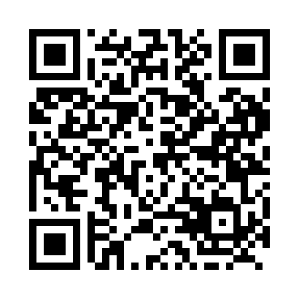
Prayer times for Montreal, Quebec, Canada
Mon 1 Apr 2024 - Tue 30 Apr 2024
High Latitude Method: Angle Based Rule
Prayer Calculation Method: Islamic Society of North America
Asar Calculation Method: Hanafi

Date | Day | Fajr | Sunrise | Dhuhr | Asr | Maghrib | Isha
1 | Mon | 5:10 | 6:34 | 12:58 | 5:28 | 7:23 | 8:48
2 | Tue | 5:08 | 6:32 | 12:58 | 5:29 | 7:25 | 8:49
3 | Wed | 5:05 | 6:30 | 12:58 | 5:29 | 7:26 | 8:51
4 | Thu | 5:03 | 6:28 | 12:57 | 5:30 | 7:27 | 8:52
5 | Fri | 5:01 | 6:26 | 12:57 | 5:31 | 7:29 | 8:54
6 | Sat | 4:59 | 6:24 | 12:57 | 5:32 | 7:30 | 8:56
7 | Sun | 4:57 | 6:23 | 12:57 | 5:33 | 7:31 | 8:57
8 | Mon | 4:55 | 6:21 | 12:56 | 5:34 | 7:33 | 8:59
9 | Tue | 4:53 | 6:19 | 12:56 | 5:35 | 7:34 | 9:00
10 | Wed | 4:50 | 6:17 | 12:56 | 5:36 | 7:35 | 9:02
11 | Thu | 4:48 | 6:15 | 12:55 | 5:36 | 7:36 | 9:04
12 | Fri | 4:46 | 6:13 | 12:55 | 5:37 | 7:38 | 9:05
13 | Sat | 4:44 | 6:12 | 12:55 | 5:38 | 7:39 | 9:07
14 | Sun | 4:42 | 6:10 | 12:55 | 5:39 | 7:40 | 9:09
15 | Mon | 4:40 | 6:08 | 12:54 | 5:40 | 7:42 | 9:10
16 | Tue | 4:38 | 6:06 | 12:54 | 5:41 | 7:43 | 9:12
17 | Wed | 4:35 | 6:05 | 12:54 | 5:42 | 7:44 | 9:14
18 | Thu | 4:33 | 6:03 | 12:54 | 5:42 | 7:45 | 9:15
19 | Fri | 4:31 | 6:01 | 12:54 | 5:43 | 7:47 | 9:17
20 | Sat | 4:29 | 5:59 | 12:53 | 5:44 | 7:48 | 9:19
21 | Sun | 4:27 | 5:58 | 12:53 | 5:45 | 7:49 | 9:20
22 | Mon | 4:25 | 5:56 | 12:53 | 5:46 | 7:51 | 9:22
23 | Tue | 4:23 | 5:54 | 12:53 | 5:46 | 7:52 | 9:24
24 | Wed | 4:21 | 5:53 | 12:53 | 5:47 | 7:53 | 9:26
25 | Thu | 4:18 | 5:51 | 12:52 | 5:48 | 7:54 | 9:27
26 | Fri | 4:16 | 5:50 | 12:52 | 5:49 | 7:56 | 9:29
27 | Sat | 4:14 | 5:48 | 12:52 | 5:50 | 7:57 | 9:31
28 | Sun | 4:12 | 5:46 | 12:52 | 5:50 | 7:58 | 9:33
29 | Mon | 4:10 | 5:45 | 12:52 | 5:51 | 8:00 | 9:35
30 | Tue | 4:08 | 5:43 | 12:52 | 5:52 | 8:01 | 9:36
Prayer times provided by https://www.salahtimes.com

