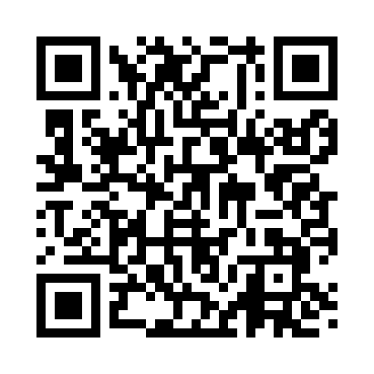
Prayer times for Asheboro, North Carolina, USA
Mon 1 Jul 2024 - Wed 31 Jul 2024
High Latitude Method: Angle Based Rule
Prayer Calculation Method: Islamic Society of North America
Asar Calculation Method: Shafi

Date | Day | Fajr | Sunrise | Dhuhr | Asr | Maghrib | Isha
1 | Mon | 4:40 | 6:07 | 1:23 | 5:12 | 8:39 | 10:06
2 | Tue | 4:41 | 6:08 | 1:23 | 5:13 | 8:39 | 10:06
3 | Wed | 4:42 | 6:08 | 1:24 | 5:13 | 8:39 | 10:05
4 | Thu | 4:42 | 6:09 | 1:24 | 5:13 | 8:39 | 10:05
5 | Fri | 4:43 | 6:09 | 1:24 | 5:13 | 8:39 | 10:05
6 | Sat | 4:44 | 6:10 | 1:24 | 5:13 | 8:38 | 10:04
7 | Sun | 4:44 | 6:10 | 1:24 | 5:13 | 8:38 | 10:04
8 | Mon | 4:45 | 6:11 | 1:24 | 5:13 | 8:38 | 10:04
9 | Tue | 4:46 | 6:11 | 1:25 | 5:13 | 8:38 | 10:03
10 | Wed | 4:47 | 6:12 | 1:25 | 5:14 | 8:37 | 10:03
11 | Thu | 4:47 | 6:13 | 1:25 | 5:14 | 8:37 | 10:02
12 | Fri | 4:48 | 6:13 | 1:25 | 5:14 | 8:36 | 10:01
13 | Sat | 4:49 | 6:14 | 1:25 | 5:14 | 8:36 | 10:01
14 | Sun | 4:50 | 6:15 | 1:25 | 5:14 | 8:36 | 10:00
15 | Mon | 4:51 | 6:15 | 1:25 | 5:14 | 8:35 | 9:59
16 | Tue | 4:52 | 6:16 | 1:25 | 5:14 | 8:35 | 9:59
17 | Wed | 4:53 | 6:17 | 1:26 | 5:14 | 8:34 | 9:58
18 | Thu | 4:54 | 6:17 | 1:26 | 5:14 | 8:34 | 9:57
19 | Fri | 4:55 | 6:18 | 1:26 | 5:14 | 8:33 | 9:56
20 | Sat | 4:56 | 6:19 | 1:26 | 5:14 | 8:32 | 9:55
21 | Sun | 4:56 | 6:19 | 1:26 | 5:14 | 8:32 | 9:54
22 | Mon | 4:57 | 6:20 | 1:26 | 5:14 | 8:31 | 9:54
23 | Tue | 4:58 | 6:21 | 1:26 | 5:14 | 8:30 | 9:53
24 | Wed | 4:59 | 6:22 | 1:26 | 5:14 | 8:30 | 9:52
25 | Thu | 5:00 | 6:22 | 1:26 | 5:14 | 8:29 | 9:51
26 | Fri | 5:01 | 6:23 | 1:26 | 5:13 | 8:28 | 9:50
27 | Sat | 5:03 | 6:24 | 1:26 | 5:13 | 8:27 | 9:49
28 | Sun | 5:04 | 6:25 | 1:26 | 5:13 | 8:27 | 9:47
29 | Mon | 5:05 | 6:25 | 1:26 | 5:13 | 8:26 | 9:46
30 | Tue | 5:06 | 6:26 | 1:26 | 5:13 | 8:25 | 9:45
31 | Wed | 5:07 | 6:27 | 1:26 | 5:13 | 8:24 | 9:44
Prayer times provided by https://www.salahtimes.com

