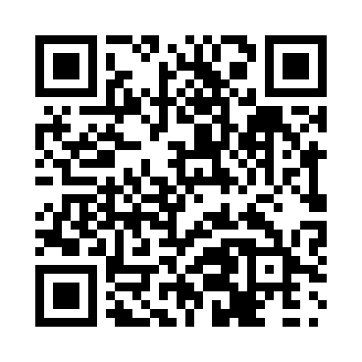
Prayer times for Glovertown, Newfoundland and Labrador, Canada
Wed 1 May 2024 - Fri 31 May 2024
High Latitude Method: Angle Based Rule
Prayer Calculation Method: Islamic Society of North America
Asar Calculation Method: Hanafi

Date | Day | Fajr | Sunrise | Dhuhr | Asr | Maghrib | Isha
1 | Wed | 4:00 | 5:45 | 1:03 | 6:07 | 8:22 | 10:08
2 | Thu | 3:58 | 5:44 | 1:03 | 6:08 | 8:23 | 10:10
3 | Fri | 3:55 | 5:42 | 1:03 | 6:09 | 8:25 | 10:12
4 | Sat | 3:53 | 5:40 | 1:03 | 6:10 | 8:26 | 10:14
5 | Sun | 3:50 | 5:39 | 1:03 | 6:11 | 8:28 | 10:16
6 | Mon | 3:48 | 5:37 | 1:03 | 6:12 | 8:29 | 10:19
7 | Tue | 3:46 | 5:36 | 1:03 | 6:13 | 8:30 | 10:21
8 | Wed | 3:43 | 5:34 | 1:03 | 6:14 | 8:32 | 10:23
9 | Thu | 3:41 | 5:33 | 1:03 | 6:14 | 8:33 | 10:25
10 | Fri | 3:39 | 5:31 | 1:03 | 6:15 | 8:35 | 10:28
11 | Sat | 3:36 | 5:30 | 1:03 | 6:16 | 8:36 | 10:30
12 | Sun | 3:34 | 5:28 | 1:03 | 6:17 | 8:37 | 10:32
13 | Mon | 3:32 | 5:27 | 1:02 | 6:18 | 8:39 | 10:34
14 | Tue | 3:30 | 5:26 | 1:03 | 6:18 | 8:40 | 10:37
15 | Wed | 3:27 | 5:24 | 1:03 | 6:19 | 8:41 | 10:39
16 | Thu | 3:25 | 5:23 | 1:03 | 6:20 | 8:43 | 10:41
17 | Fri | 3:23 | 5:22 | 1:03 | 6:21 | 8:44 | 10:43
18 | Sat | 3:21 | 5:21 | 1:03 | 6:22 | 8:45 | 10:46
19 | Sun | 3:19 | 5:19 | 1:03 | 6:22 | 8:47 | 10:48
20 | Mon | 3:17 | 5:18 | 1:03 | 6:23 | 8:48 | 10:50
21 | Tue | 3:15 | 5:17 | 1:03 | 6:24 | 8:49 | 10:52
22 | Wed | 3:12 | 5:16 | 1:03 | 6:24 | 8:50 | 10:54
23 | Thu | 3:10 | 5:15 | 1:03 | 6:25 | 8:51 | 10:57
24 | Fri | 3:09 | 5:14 | 1:03 | 6:26 | 8:53 | 10:58
25 | Sat | 3:08 | 5:13 | 1:03 | 6:27 | 8:54 | 10:59
26 | Sun | 3:08 | 5:12 | 1:03 | 6:27 | 8:55 | 10:59
27 | Mon | 3:07 | 5:11 | 1:03 | 6:28 | 8:56 | 11:00
28 | Tue | 3:07 | 5:10 | 1:04 | 6:29 | 8:57 | 11:00
29 | Wed | 3:07 | 5:10 | 1:04 | 6:29 | 8:58 | 11:01
30 | Thu | 3:06 | 5:09 | 1:04 | 6:30 | 8:59 | 11:02
31 | Fri | 3:06 | 5:08 | 1:04 | 6:30 | 9:00 | 11:02
Prayer times provided by https://www.salahtimes.com

