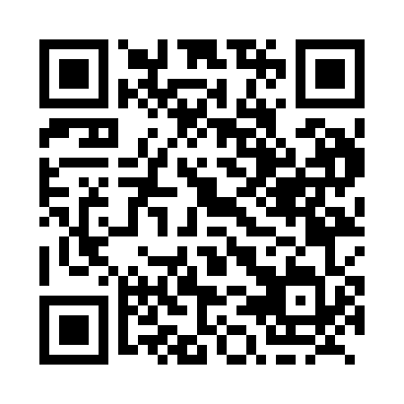
Prayer times for Boggy Hall, Alberta, Canada
Mon 1 Jul 2024 - Wed 31 Jul 2024
High Latitude Method: Angle Based Rule
Prayer Calculation Method: Islamic Society of North America
Asar Calculation Method: Hanafi

Date | Day | Fajr | Sunrise | Dhuhr | Asr | Maghrib | Isha
1 | Mon | 3:32 | 5:20 | 1:45 | 7:25 | 10:10 | 11:57
2 | Tue | 3:33 | 5:21 | 1:45 | 7:24 | 10:09 | 11:57
3 | Wed | 3:33 | 5:22 | 1:45 | 7:24 | 10:09 | 11:57
4 | Thu | 3:34 | 5:22 | 1:46 | 7:24 | 10:08 | 11:57
5 | Fri | 3:34 | 5:23 | 1:46 | 7:24 | 10:08 | 11:57
6 | Sat | 3:35 | 5:24 | 1:46 | 7:24 | 10:07 | 11:56
7 | Sun | 3:36 | 5:25 | 1:46 | 7:23 | 10:06 | 11:56
8 | Mon | 3:36 | 5:26 | 1:46 | 7:23 | 10:05 | 11:56
9 | Tue | 3:37 | 5:27 | 1:46 | 7:23 | 10:05 | 11:55
10 | Wed | 3:37 | 5:29 | 1:46 | 7:22 | 10:04 | 11:55
11 | Thu | 3:38 | 5:30 | 1:47 | 7:22 | 10:03 | 11:55
12 | Fri | 3:39 | 5:31 | 1:47 | 7:21 | 10:02 | 11:54
13 | Sat | 3:39 | 5:32 | 1:47 | 7:21 | 10:01 | 11:54
14 | Sun | 3:40 | 5:33 | 1:47 | 7:20 | 10:00 | 11:53
15 | Mon | 3:41 | 5:35 | 1:47 | 7:20 | 9:59 | 11:53
16 | Tue | 3:41 | 5:36 | 1:47 | 7:19 | 9:58 | 11:52
17 | Wed | 3:42 | 5:37 | 1:47 | 7:19 | 9:56 | 11:52
18 | Thu | 3:43 | 5:39 | 1:47 | 7:18 | 9:55 | 11:51
19 | Fri | 3:44 | 5:40 | 1:47 | 7:17 | 9:54 | 11:50
20 | Sat | 3:44 | 5:41 | 1:47 | 7:17 | 9:53 | 11:50
21 | Sun | 3:45 | 5:43 | 1:47 | 7:16 | 9:51 | 11:49
22 | Mon | 3:46 | 5:44 | 1:47 | 7:15 | 9:50 | 11:48
23 | Tue | 3:46 | 5:46 | 1:47 | 7:14 | 9:48 | 11:48
24 | Wed | 3:47 | 5:47 | 1:47 | 7:13 | 9:47 | 11:47
25 | Thu | 3:48 | 5:49 | 1:47 | 7:13 | 9:45 | 11:46
26 | Fri | 3:49 | 5:50 | 1:47 | 7:12 | 9:44 | 11:45
27 | Sat | 3:49 | 5:52 | 1:47 | 7:11 | 9:42 | 11:45
28 | Sun | 3:50 | 5:53 | 1:47 | 7:10 | 9:41 | 11:44
29 | Mon | 3:51 | 5:55 | 1:47 | 7:09 | 9:39 | 11:43
30 | Tue | 3:52 | 5:57 | 1:47 | 7:08 | 9:37 | 11:42
31 | Wed | 3:53 | 5:58 | 1:47 | 7:07 | 9:35 | 11:41
Prayer times provided by https://www.salahtimes.com

