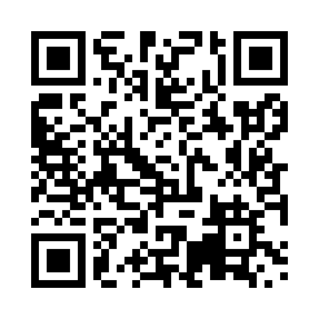
Prayer times for Lac Baker, New Brunswick, Canada
Mon 1 Jul 2024 - Wed 31 Jul 2024
High Latitude Method: Angle Based Rule
Prayer Calculation Method: Islamic Society of North America
Asar Calculation Method: Hanafi

Date | Day | Fajr | Sunrise | Dhuhr | Asr | Maghrib | Isha
1 | Mon | 3:40 | 5:42 | 1:39 | 7:05 | 9:34 | 11:36
2 | Tue | 3:41 | 5:43 | 1:39 | 7:05 | 9:34 | 11:36
3 | Wed | 3:41 | 5:44 | 1:39 | 7:05 | 9:34 | 11:36
4 | Thu | 3:42 | 5:44 | 1:39 | 7:05 | 9:34 | 11:36
5 | Fri | 3:42 | 5:45 | 1:39 | 7:05 | 9:33 | 11:36
6 | Sat | 3:43 | 5:46 | 1:39 | 7:05 | 9:33 | 11:36
7 | Sun | 3:43 | 5:47 | 1:40 | 7:05 | 9:32 | 11:36
8 | Mon | 3:44 | 5:48 | 1:40 | 7:04 | 9:32 | 11:36
9 | Tue | 3:44 | 5:48 | 1:40 | 7:04 | 9:31 | 11:35
10 | Wed | 3:46 | 5:49 | 1:40 | 7:04 | 9:30 | 11:34
11 | Thu | 3:47 | 5:50 | 1:40 | 7:04 | 9:30 | 11:32
12 | Fri | 3:49 | 5:51 | 1:40 | 7:03 | 9:29 | 11:31
13 | Sat | 3:50 | 5:52 | 1:40 | 7:03 | 9:28 | 11:30
14 | Sun | 3:52 | 5:53 | 1:41 | 7:03 | 9:28 | 11:28
15 | Mon | 3:54 | 5:54 | 1:41 | 7:02 | 9:27 | 11:26
16 | Tue | 3:56 | 5:55 | 1:41 | 7:02 | 9:26 | 11:25
17 | Wed | 3:57 | 5:56 | 1:41 | 7:01 | 9:25 | 11:23
18 | Thu | 3:59 | 5:57 | 1:41 | 7:01 | 9:24 | 11:22
19 | Fri | 4:01 | 5:58 | 1:41 | 7:00 | 9:23 | 11:20
20 | Sat | 4:03 | 5:59 | 1:41 | 7:00 | 9:22 | 11:18
21 | Sun | 4:05 | 6:01 | 1:41 | 6:59 | 9:21 | 11:16
22 | Mon | 4:07 | 6:02 | 1:41 | 6:59 | 9:20 | 11:14
23 | Tue | 4:09 | 6:03 | 1:41 | 6:58 | 9:19 | 11:12
24 | Wed | 4:11 | 6:04 | 1:41 | 6:57 | 9:18 | 11:11
25 | Thu | 4:13 | 6:05 | 1:41 | 6:57 | 9:17 | 11:09
26 | Fri | 4:15 | 6:06 | 1:41 | 6:56 | 9:15 | 11:07
27 | Sat | 4:17 | 6:08 | 1:41 | 6:55 | 9:14 | 11:05
28 | Sun | 4:19 | 6:09 | 1:41 | 6:55 | 9:13 | 11:03
29 | Mon | 4:20 | 6:10 | 1:41 | 6:54 | 9:12 | 11:01
30 | Tue | 4:22 | 6:11 | 1:41 | 6:53 | 9:10 | 10:58
31 | Wed | 4:24 | 6:12 | 1:41 | 6:52 | 9:09 | 10:56
Prayer times provided by https://www.salahtimes.com

