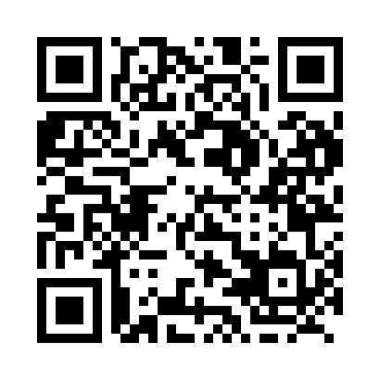
Prayer times for Upper Charlo, New Brunswick, Canada
Wed 1 May 2024 - Fri 31 May 2024
High Latitude Method: Angle Based Rule
Prayer Calculation Method: Islamic Society of North America
Asar Calculation Method: Hanafi

Date | Day | Fajr | Sunrise | Dhuhr | Asr | Maghrib | Isha
1 | Wed | 4:23 | 6:06 | 1:22 | 6:26 | 8:39 | 10:23
2 | Thu | 4:21 | 6:05 | 1:22 | 6:27 | 8:41 | 10:25
3 | Fri | 4:19 | 6:03 | 1:22 | 6:28 | 8:42 | 10:27
4 | Sat | 4:16 | 6:01 | 1:22 | 6:29 | 8:43 | 10:29
5 | Sun | 4:14 | 6:00 | 1:22 | 6:29 | 8:45 | 10:31
6 | Mon | 4:12 | 5:58 | 1:22 | 6:30 | 8:46 | 10:33
7 | Tue | 4:10 | 5:57 | 1:22 | 6:31 | 8:48 | 10:35
8 | Wed | 4:07 | 5:55 | 1:22 | 6:32 | 8:49 | 10:38
9 | Thu | 4:05 | 5:54 | 1:22 | 6:33 | 8:50 | 10:40
10 | Fri | 4:03 | 5:53 | 1:22 | 6:33 | 8:52 | 10:42
11 | Sat | 4:01 | 5:51 | 1:22 | 6:34 | 8:53 | 10:44
12 | Sun | 3:59 | 5:50 | 1:22 | 6:35 | 8:54 | 10:46
13 | Mon | 3:56 | 5:48 | 1:22 | 6:36 | 8:56 | 10:48
14 | Tue | 3:54 | 5:47 | 1:22 | 6:37 | 8:57 | 10:50
15 | Wed | 3:52 | 5:46 | 1:22 | 6:37 | 8:58 | 10:52
16 | Thu | 3:50 | 5:45 | 1:22 | 6:38 | 9:00 | 10:55
17 | Fri | 3:48 | 5:43 | 1:22 | 6:39 | 9:01 | 10:57
18 | Sat | 3:46 | 5:42 | 1:22 | 6:40 | 9:02 | 10:59
19 | Sun | 3:44 | 5:41 | 1:22 | 6:40 | 9:03 | 11:01
20 | Mon | 3:42 | 5:40 | 1:22 | 6:41 | 9:04 | 11:03
21 | Tue | 3:40 | 5:39 | 1:22 | 6:42 | 9:06 | 11:05
22 | Wed | 3:38 | 5:38 | 1:22 | 6:42 | 9:07 | 11:07
23 | Thu | 3:36 | 5:37 | 1:22 | 6:43 | 9:08 | 11:09
24 | Fri | 3:35 | 5:36 | 1:22 | 6:44 | 9:09 | 11:11
25 | Sat | 3:33 | 5:35 | 1:22 | 6:45 | 9:10 | 11:13
26 | Sun | 3:31 | 5:34 | 1:22 | 6:45 | 9:11 | 11:15
27 | Mon | 3:29 | 5:33 | 1:23 | 6:46 | 9:12 | 11:17
28 | Tue | 3:28 | 5:33 | 1:23 | 6:46 | 9:13 | 11:18
29 | Wed | 3:27 | 5:32 | 1:23 | 6:47 | 9:14 | 11:19
30 | Thu | 3:27 | 5:31 | 1:23 | 6:48 | 9:15 | 11:19
31 | Fri | 3:27 | 5:30 | 1:23 | 6:48 | 9:16 | 11:20
Prayer times provided by https://www.salahtimes.com

