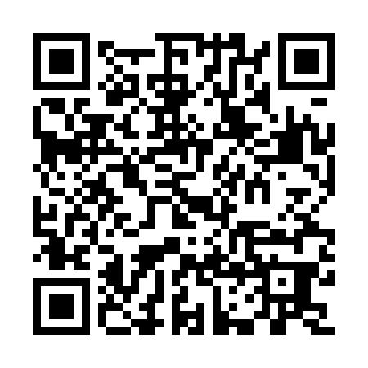
Prayer times for Unter Hiltersklingen, Germany
Mon 1 Apr 2024 - Tue 30 Apr 2024
High Latitude Method: Angle Based Rule
Prayer Calculation Method: Muslim World League
Asar Calculation Method: Shafi

Date | Day | Fajr | Sunrise | Dhuhr | Asr | Maghrib | Isha
1 | Mon | 5:08 | 7:01 | 1:28 | 5:02 | 7:57 | 9:43
2 | Tue | 5:05 | 6:59 | 1:28 | 5:03 | 7:58 | 9:45
3 | Wed | 5:02 | 6:56 | 1:28 | 5:04 | 8:00 | 9:47
4 | Thu | 5:00 | 6:54 | 1:27 | 5:04 | 8:01 | 9:49
5 | Fri | 4:57 | 6:52 | 1:27 | 5:05 | 8:03 | 9:51
6 | Sat | 4:54 | 6:50 | 1:27 | 5:06 | 8:04 | 9:53
7 | Sun | 4:52 | 6:48 | 1:26 | 5:07 | 8:06 | 9:55
8 | Mon | 4:49 | 6:46 | 1:26 | 5:07 | 8:07 | 9:57
9 | Tue | 4:46 | 6:44 | 1:26 | 5:08 | 8:09 | 9:59
10 | Wed | 4:44 | 6:42 | 1:26 | 5:09 | 8:10 | 10:01
11 | Thu | 4:41 | 6:40 | 1:25 | 5:10 | 8:12 | 10:03
12 | Fri | 4:38 | 6:38 | 1:25 | 5:10 | 8:14 | 10:06
13 | Sat | 4:35 | 6:35 | 1:25 | 5:11 | 8:15 | 10:08
14 | Sun | 4:33 | 6:33 | 1:25 | 5:12 | 8:17 | 10:10
15 | Mon | 4:30 | 6:31 | 1:24 | 5:12 | 8:18 | 10:12
16 | Tue | 4:27 | 6:29 | 1:24 | 5:13 | 8:20 | 10:14
17 | Wed | 4:24 | 6:27 | 1:24 | 5:14 | 8:21 | 10:17
18 | Thu | 4:21 | 6:25 | 1:24 | 5:14 | 8:23 | 10:19
19 | Fri | 4:18 | 6:23 | 1:23 | 5:15 | 8:24 | 10:21
20 | Sat | 4:16 | 6:21 | 1:23 | 5:16 | 8:26 | 10:24
21 | Sun | 4:13 | 6:20 | 1:23 | 5:16 | 8:27 | 10:26
22 | Mon | 4:10 | 6:18 | 1:23 | 5:17 | 8:29 | 10:28
23 | Tue | 4:07 | 6:16 | 1:23 | 5:18 | 8:30 | 10:31
24 | Wed | 4:04 | 6:14 | 1:22 | 5:18 | 8:32 | 10:33
25 | Thu | 4:01 | 6:12 | 1:22 | 5:19 | 8:34 | 10:36
26 | Fri | 3:58 | 6:10 | 1:22 | 5:20 | 8:35 | 10:38
27 | Sat | 3:55 | 6:08 | 1:22 | 5:20 | 8:37 | 10:41
28 | Sun | 3:52 | 6:06 | 1:22 | 5:21 | 8:38 | 10:43
29 | Mon | 3:49 | 6:05 | 1:22 | 5:21 | 8:40 | 10:46
30 | Tue | 3:46 | 6:03 | 1:22 | 5:22 | 8:41 | 10:48
Prayer times provided by https://www.salahtimes.com

