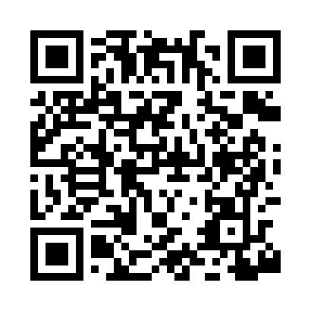
Prayer times for Bell Crossing, Montana, USA
Wed 1 May 2024 - Fri 31 May 2024
High Latitude Method: Angle Based Rule
Prayer Calculation Method: Islamic Society of North America
Asar Calculation Method: Shafi

Date | Day | Fajr | Sunrise | Dhuhr | Asr | Maghrib | Isha
1 | Wed | 4:43 | 6:21 | 1:34 | 5:32 | 8:46 | 10:25
2 | Thu | 4:41 | 6:20 | 1:33 | 5:32 | 8:48 | 10:27
3 | Fri | 4:39 | 6:18 | 1:33 | 5:33 | 8:49 | 10:29
4 | Sat | 4:37 | 6:17 | 1:33 | 5:33 | 8:50 | 10:31
5 | Sun | 4:35 | 6:15 | 1:33 | 5:33 | 8:52 | 10:33
6 | Mon | 4:32 | 6:14 | 1:33 | 5:34 | 8:53 | 10:35
7 | Tue | 4:30 | 6:12 | 1:33 | 5:34 | 8:54 | 10:37
8 | Wed | 4:28 | 6:11 | 1:33 | 5:35 | 8:56 | 10:39
9 | Thu | 4:26 | 6:10 | 1:33 | 5:35 | 8:57 | 10:41
10 | Fri | 4:24 | 6:08 | 1:33 | 5:36 | 8:58 | 10:42
11 | Sat | 4:22 | 6:07 | 1:33 | 5:36 | 8:59 | 10:44
12 | Sun | 4:20 | 6:06 | 1:33 | 5:37 | 9:01 | 10:46
13 | Mon | 4:19 | 6:05 | 1:33 | 5:37 | 9:02 | 10:48
14 | Tue | 4:17 | 6:03 | 1:33 | 5:37 | 9:03 | 10:50
15 | Wed | 4:15 | 6:02 | 1:33 | 5:38 | 9:04 | 10:52
16 | Thu | 4:13 | 6:01 | 1:33 | 5:38 | 9:05 | 10:54
17 | Fri | 4:11 | 6:00 | 1:33 | 5:39 | 9:07 | 10:56
18 | Sat | 4:09 | 5:59 | 1:33 | 5:39 | 9:08 | 10:58
19 | Sun | 4:08 | 5:58 | 1:33 | 5:40 | 9:09 | 10:59
20 | Mon | 4:06 | 5:57 | 1:33 | 5:40 | 9:10 | 11:01
21 | Tue | 4:04 | 5:56 | 1:33 | 5:40 | 9:11 | 11:03
22 | Wed | 4:03 | 5:55 | 1:33 | 5:41 | 9:12 | 11:05
23 | Thu | 4:01 | 5:54 | 1:33 | 5:41 | 9:13 | 11:07
24 | Fri | 3:59 | 5:53 | 1:33 | 5:42 | 9:14 | 11:08
25 | Sat | 3:58 | 5:52 | 1:34 | 5:42 | 9:15 | 11:10
26 | Sun | 3:56 | 5:51 | 1:34 | 5:43 | 9:17 | 11:12
27 | Mon | 3:55 | 5:50 | 1:34 | 5:43 | 9:18 | 11:13
28 | Tue | 3:54 | 5:50 | 1:34 | 5:43 | 9:18 | 11:15
29 | Wed | 3:52 | 5:49 | 1:34 | 5:44 | 9:19 | 11:17
30 | Thu | 3:51 | 5:48 | 1:34 | 5:44 | 9:20 | 11:18
31 | Fri | 3:50 | 5:48 | 1:34 | 5:44 | 9:21 | 11:20
Prayer times provided by https://www.salahtimes.com

