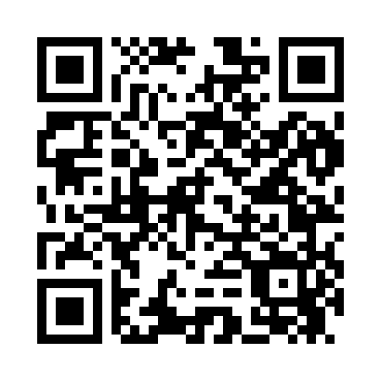
Prayer times for Alligator Lake, South Carolina, USA
Wed 1 May 2024 - Fri 31 May 2024
High Latitude Method: Angle Based Rule
Prayer Calculation Method: Islamic Society of North America
Asar Calculation Method: Shafi

Date | Day | Fajr | Sunrise | Dhuhr | Asr | Maghrib | Isha
1 | Wed | 5:14 | 6:29 | 1:16 | 4:59 | 8:04 | 9:19
2 | Thu | 5:13 | 6:28 | 1:16 | 4:59 | 8:04 | 9:20
3 | Fri | 5:11 | 6:27 | 1:16 | 4:59 | 8:05 | 9:21
4 | Sat | 5:10 | 6:26 | 1:16 | 4:59 | 8:06 | 9:22
5 | Sun | 5:09 | 6:25 | 1:16 | 4:59 | 8:07 | 9:23
6 | Mon | 5:08 | 6:24 | 1:16 | 4:59 | 8:08 | 9:24
7 | Tue | 5:07 | 6:24 | 1:16 | 5:00 | 8:08 | 9:25
8 | Wed | 5:05 | 6:23 | 1:16 | 5:00 | 8:09 | 9:27
9 | Thu | 5:04 | 6:22 | 1:16 | 5:00 | 8:10 | 9:28
10 | Fri | 5:03 | 6:21 | 1:16 | 5:00 | 8:11 | 9:29
11 | Sat | 5:02 | 6:20 | 1:16 | 5:00 | 8:11 | 9:30
12 | Sun | 5:01 | 6:19 | 1:16 | 5:00 | 8:12 | 9:31
13 | Mon | 5:00 | 6:19 | 1:16 | 5:00 | 8:13 | 9:32
14 | Tue | 4:59 | 6:18 | 1:16 | 5:00 | 8:14 | 9:33
15 | Wed | 4:58 | 6:17 | 1:16 | 5:00 | 8:14 | 9:34
16 | Thu | 4:57 | 6:16 | 1:16 | 5:00 | 8:15 | 9:35
17 | Fri | 4:56 | 6:16 | 1:16 | 5:00 | 8:16 | 9:36
18 | Sat | 4:55 | 6:15 | 1:16 | 5:01 | 8:17 | 9:37
19 | Sun | 4:54 | 6:14 | 1:16 | 5:01 | 8:17 | 9:38
20 | Mon | 4:54 | 6:14 | 1:16 | 5:01 | 8:18 | 9:38
21 | Tue | 4:53 | 6:13 | 1:16 | 5:01 | 8:19 | 9:39
22 | Wed | 4:52 | 6:13 | 1:16 | 5:01 | 8:20 | 9:40
23 | Thu | 4:51 | 6:12 | 1:16 | 5:01 | 8:20 | 9:41
24 | Fri | 4:51 | 6:12 | 1:16 | 5:01 | 8:21 | 9:42
25 | Sat | 4:50 | 6:11 | 1:16 | 5:01 | 8:22 | 9:43
26 | Sun | 4:49 | 6:11 | 1:16 | 5:02 | 8:22 | 9:44
27 | Mon | 4:49 | 6:10 | 1:16 | 5:02 | 8:23 | 9:45
28 | Tue | 4:48 | 6:10 | 1:17 | 5:02 | 8:24 | 9:46
29 | Wed | 4:47 | 6:10 | 1:17 | 5:02 | 8:24 | 9:47
30 | Thu | 4:47 | 6:09 | 1:17 | 5:02 | 8:25 | 9:47
31 | Fri | 4:46 | 6:09 | 1:17 | 5:02 | 8:25 | 9:48
Prayer times provided by https://www.salahtimes.com

