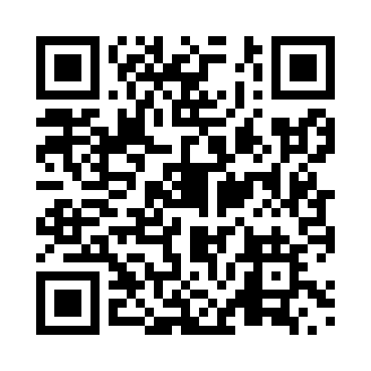
Prayer times for Brill, Quebec, Canada
Wed 1 May 2024 - Fri 31 May 2024
High Latitude Method: Angle Based Rule
Prayer Calculation Method: Islamic Society of North America
Asar Calculation Method: Hanafi

Date | Day | Fajr | Sunrise | Dhuhr | Asr | Maghrib | Isha
1 | Wed | 4:03 | 5:38 | 12:47 | 5:47 | 7:57 | 9:32
2 | Thu | 4:01 | 5:36 | 12:47 | 5:48 | 7:58 | 9:34
3 | Fri | 3:59 | 5:35 | 12:47 | 5:49 | 7:59 | 9:36
4 | Sat | 3:57 | 5:33 | 12:46 | 5:50 | 8:00 | 9:37
5 | Sun | 3:55 | 5:32 | 12:46 | 5:50 | 8:02 | 9:39
6 | Mon | 3:53 | 5:30 | 12:46 | 5:51 | 8:03 | 9:41
7 | Tue | 3:51 | 5:29 | 12:46 | 5:52 | 8:04 | 9:43
8 | Wed | 3:49 | 5:28 | 12:46 | 5:53 | 8:05 | 9:45
9 | Thu | 3:47 | 5:26 | 12:46 | 5:53 | 8:07 | 9:46
10 | Fri | 3:45 | 5:25 | 12:46 | 5:54 | 8:08 | 9:48
11 | Sat | 3:43 | 5:24 | 12:46 | 5:55 | 8:09 | 9:50
12 | Sun | 3:42 | 5:23 | 12:46 | 5:55 | 8:10 | 9:52
13 | Mon | 3:40 | 5:22 | 12:46 | 5:56 | 8:11 | 9:53
14 | Tue | 3:38 | 5:20 | 12:46 | 5:57 | 8:12 | 9:55
15 | Wed | 3:36 | 5:19 | 12:46 | 5:58 | 8:14 | 9:57
16 | Thu | 3:35 | 5:18 | 12:46 | 5:58 | 8:15 | 9:59
17 | Fri | 3:33 | 5:17 | 12:46 | 5:59 | 8:16 | 10:00
18 | Sat | 3:31 | 5:16 | 12:46 | 6:00 | 8:17 | 10:02
19 | Sun | 3:30 | 5:15 | 12:46 | 6:00 | 8:18 | 10:04
20 | Mon | 3:28 | 5:14 | 12:46 | 6:01 | 8:19 | 10:06
21 | Tue | 3:26 | 5:13 | 12:46 | 6:01 | 8:20 | 10:07
22 | Wed | 3:25 | 5:12 | 12:46 | 6:02 | 8:21 | 10:09
23 | Thu | 3:23 | 5:11 | 12:47 | 6:03 | 8:22 | 10:11
24 | Fri | 3:22 | 5:10 | 12:47 | 6:03 | 8:23 | 10:12
25 | Sat | 3:21 | 5:10 | 12:47 | 6:04 | 8:24 | 10:14
26 | Sun | 3:19 | 5:09 | 12:47 | 6:05 | 8:25 | 10:15
27 | Mon | 3:18 | 5:08 | 12:47 | 6:05 | 8:26 | 10:17
28 | Tue | 3:17 | 5:07 | 12:47 | 6:06 | 8:27 | 10:18
29 | Wed | 3:16 | 5:07 | 12:47 | 6:06 | 8:28 | 10:20
30 | Thu | 3:14 | 5:06 | 12:47 | 6:07 | 8:29 | 10:21
31 | Fri | 3:13 | 5:06 | 12:48 | 6:07 | 8:30 | 10:23
Prayer times provided by https://www.salahtimes.com

